Michelle Dahiana Hernández 9-2

EXERCISES

A. FILL IN THE BLANKS WITH A SUITABLE CONTRAST CONNECTOR ( WHEREAS, BUT,

ALTHOUGH, HOWEVER, DESPITE, IN SPITE OF, ON THE OTHER HAND)

1. ______ALTHOUGH_______ Andrew was warned of the risks, he decided to travel alone to South

America.

2. Maria did not get a promotion _______ DESPITE_______ her qualifications.

3. Zambia is a land- locked country, ____ HOWEVER________ Kenya has a coastline.

4. On the one hand, you could rent a flat instead of buying one. _____BUT_____ you are

always at the mercy of landlords.

5. This restaurant has a good reputation, WHEREAS that one does not.

6. The city has a 50 kph limit. ___BUT_____, people are often caught speeding.

7. You won’t be forgiven ___ HOWEVER your apology.

8. We couldn’t find a house to buy _____ ALTHOUGH we looked at quite a few.

9. He always looks so lonely and sad ___ DESPITE his popularity.

10. He is quiet and shy, __BUT___his sister is lively and talkative

1. Dave smokes. He seems to be in good health (although)

2. I couldn’t sleep. I was tired. (despite)

3. Max didn’t notice the sign. It was right in front of him (even though)

4. Kate never learnt Spanish. She lived in Spain for many years (although)

5. Joe is a millionaire .He hates spending money. (despite)

Daisy: Are you and Alfie going to the festival this weekend?

Oliver: Hmm? We want to, but we don't have a car so we're not sure how to

get there. It's in the middle of nowhere!

Daisy: Amy's dad is taking us on Saturday morning, and he's offered to bring

us home again on Sunday. Why not come with us?

Oliver: But where would we sleep? You can't fit five adults and tents in one

car.

Daisy: You can in his – it's one of those cars for seven people, so there's plenty

of room. Although we could look for a bed and breakfast in the village near

the festival, if you'd rather.

Oliver: No, no, brilliant! Camping and concerts. A great combination!

Daisy: Or camping, concerts and cooking. It's a world music festival but

there's also food from all over the world – Chile, Ethiopia, ummm ...

Oliver: Cool! Let's call Alfie and Amy, and get organised.

Alfie: Let's see ... here's the programme. The smaller concerts start at 12 but

the bigger ones start at 3. What time will we be there?

Oliver: Well, if we leave here at about 10am, we'll be there by 12. Although

we have to put up our tents too, so we could see something at 1 o'clock.

Amy: But we have to carry the tents from the car and then find a good

space, so we'll be later than that.

Daisy: A space near food and toilets, but not too near because it'll be noisy

... and busy.

Alfie: True. So, carry the tents, find a space, put the tents up ...

Amy: (interrupting) … eat ... we'll be hungry by then.

Alfie: Also true. Put the tents up, eat ... so we'll be ready for concerts at, what?

3 o’clock?

Oliver: I would think so, yes.

Amy: Isn't your mum going? World music and food sounds like the perfect

festival for her!

Daisy: I know, but she can't go even though she told me she'd really like to.

She's in Vienna. ... and speaking of Mum ... Hi, Mum, we were just talking

about you!

Sophie: All good, I hope!

Alfie: Hi, Sophie. Daisy was just saying you can't come with us all to the festival

this weekend.

Sophie: No, I'm here in Austria until Tuesday – it's the land of chocolate cake,

the waltz and Mozart, so I'm OK for food, dance and music, and I'm having

a wonderful time ... but you can take photos for me, can't you? In fact, would

you like to be guest bloggers and write a post?

Amy: Oh yes! That would be so cool!

Daisy: Great idea, Mum.

Sophie: So, my two, how are things ...?

Alfie: Wow, writing a post for Sophie's blog. Thousands of people read her

blog!

Amy: I know! And we can interview people and try lots of different food from

different places and if we organise ourselves, we can see as many concerts

as possible.

Alfie: I'd like to see that Irish band, because Celtic music is pretty cool.

Amy: There's a Portuguese singer I'd like to see.

Alfie: Oliver and Daisy could write about the food ...

Amy: Umm … yes ... maybe. Although maybe we should see what they want

to do too.

Alfie: Er, yes. Yes, we should.

Amy: But, it's a possibility.

Oliver/Daisy: OK, bye Mum. Love you.

Oliver: Bring us some cake! OK, you two, we were looking at the programme

… Concerts. Hey, at 3 o'clock there's a great looking reggae band from

Jamaica or a Russian electro-pop group on the other stage ...

Daisy/Oliver: I fancy the Russian gig – oh, haha.

Daisy: How about you two go to the reggae?

Alfie: Fine by me ...

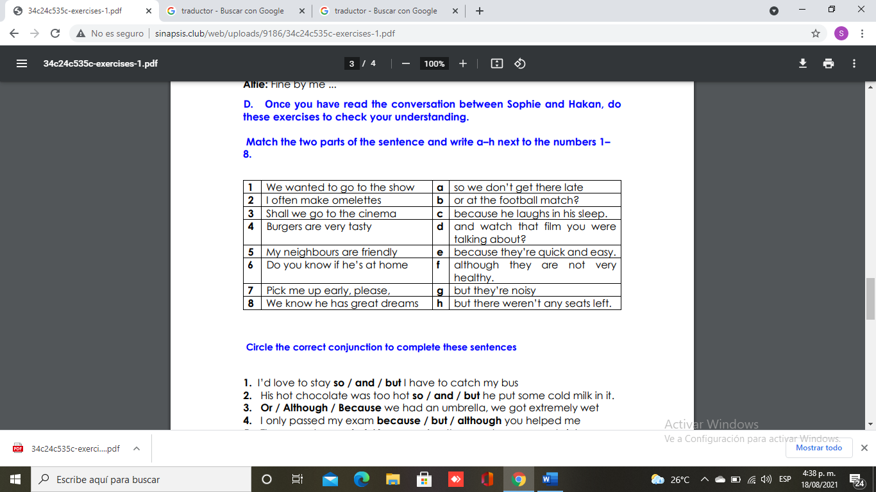

1. I’d love to stay so / and / but I have to catch my bus

2. His hot chocolate was too hot so / and / but he put some cold milk in it.

3. Or / Although / Because we had an umbrella, we got extremely wet

4. I only passed my exam because / but / although you helped me

5. They were hungry but / because / so they made some sandwiches

6. We can go to the pool and / but / or we can go horse-riding, whichever you prefer.

7. She didn’t want him to see her and / so / although she hid behind a plant

8. He’s in the town centre so / because / but he wants to look for shoes

9. I’m definitely coming tonight, or / because / although I could be a bit late