EXPRESSING OPINION

2. Answer the next questions

A. Are you listening to music as you read this?

R/: yes, electronic music

B. Answer these questions: Are the sentences true or false?British teenagers prefer the radio to YouTube videos. False

* 2. Lots of people in the UK download music. True
* 3. The O2 is the largest live music venue in the world. False
* 4. There are free music festivals in the UK every year. False
* 5. One Direction won a television music competition. False
* 6. Classical music helped to solve a problem in a British shopping centre. False

3. Find the words in the wordsearch.

R/:

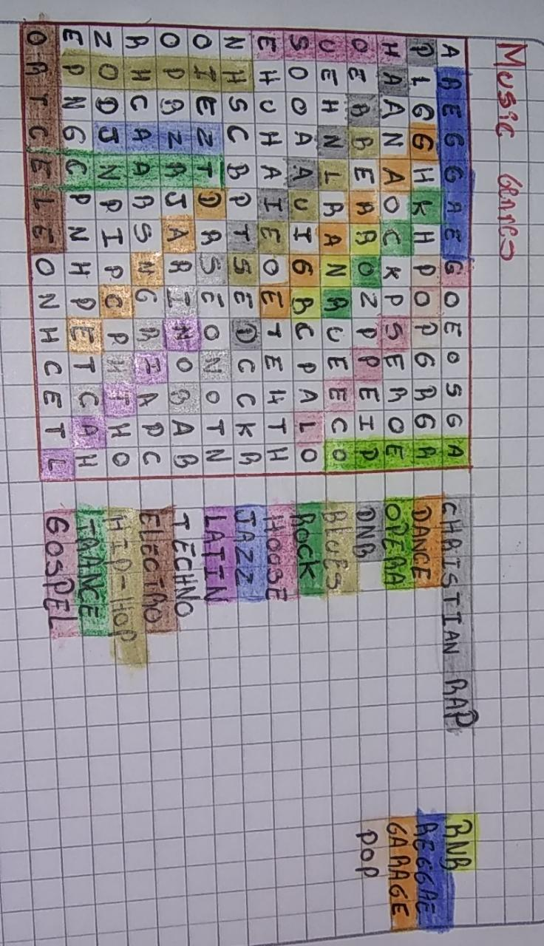

4. Write about your favourite kind of music, and one of the singers that you like a lot, use some phrases to express your opinión.

R/: I like to listen to urban music, but I also really like electronic music, in the case of urban music my favorite singer is Anuel aa, but I also really like Alan Walker's music, I like this type of music because they they make us feel happy, this type of music has a very fast and very good rhythm.

5. Choose one topic to organize a short presentation using words to express opinions, prepare slides to do the exercise.

R/: