**HOLI**

Before you read **‘HOLI’** complete the following tasks.

* What do you know about **HOLI**?
* Do you know another Indian festivity?
* In your country, what is your favorite festivity and what is the reason?

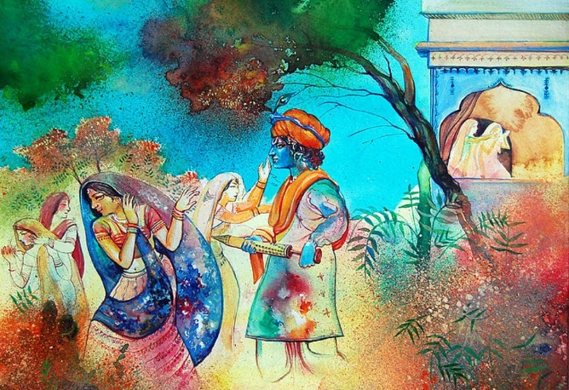Long before water balloons and pichkaaris, Holi was only an idea- an idea that transpired to become one of the most amusing festivals of the world. **Holi is the festival of colours.** But what does colour symbolize here? We are never certain. But we always hope that colouring something gives life to it. And thereby, perhaps Holi is the celebration of life itself. Holi accolades life, love, its vitality, its passion.

There are stories that date back the origin of Holi and recounts tales in mythology that trace the advent of our attempt at painting the human race more colourful. Maybe they are true, maybe they aren’t. But the essence of colour compels us to shun our logical minds in the hope of a dreamy world full of rainbows.

One of the most ancient festivals of India, Holi was also known as “Holika”. Since time immemorial, the festival finds colour in numerous scriptures, such as in works like Jaimini's Purvamimamsa-Sutras and Kathaka-Grhya-Sutras with even detailed descriptions in ancient texts like the Narad Purana and Bhavishyad Purana. The festival of “holikotsav” was also mentioned in the 7th century work, Ratnavali, by King Harsha.

The triumph of good over evil is a tried and tested theme resurfacing in early scriptures time and again. Holi is one such festival with the prime theme of good beating away evil. However, the meaning of the festival has undergone significant changes over centuries. Holi used to be a rite performed by married women praying for their family’s well-being where Raka, the full moon, was worshipped.

The origin of Holi is believed to be before the birth of Christ. Legend goes that Lord Vishnu had assassinated the younger brother of the demon lord, Hiranyakashipu. Apart from avenging his brother’s death, the demon king had the ulterior motive of ruling the heaven, the earth, and the underworld by defeating Vishnu. Powered by a boon granted to him, Hiranyakashipu thought he had become invincible. On his orders, his whole state started praying him, dismissing the gods. But his son, Prahalad, maintained his deity to be none but Vishnu. Angered, the tyrant king decided to kill Prahalad with the help of Holika, Hiranyakashipu’s sister, who was immune to fire. A pyre was lit and Holika sat on it, clutching Prahalad. But Prahalad emerged out of the fire unscathed, whereas Holika burned to ashes. Hiranyakashipu, too, was eventually killed by Vishnu. Even today, the story of Holika is re-enacted by actors on Holi. Bonfires across the country are lit up to celebrate the burning away of the evil spirits.

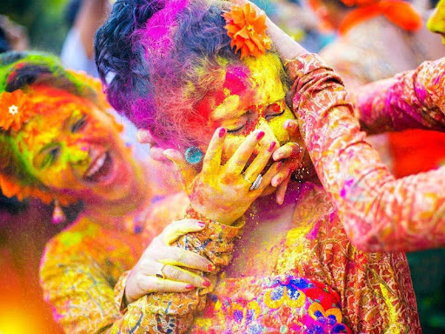Celebrated with much pomp and dignity, the Bengali “Dolyatra” marks the final celebration of a Bengali year. Dolyatra popularizes the tale of Radha and her lover, Krishna. Krishna, as a boy would drench girls with water and colours as a sport. Soon, other boys in his village started participating and somehow, it became a tradition to throw colours and water on each other on this special day. As Krishna grew, the game came to signify the colourful and eventful love story of Radha and Krishna. This tradition has transpired through ages to signify the festival of colours across the globe, with its origin solely in the Hindu mythology.

Also known as “Dol Purnima” and “Bashanta Utsav”, Holi itself is manoeuvred into several colours establishing its sense literally into our mind and soul through centuries.

**Colours:** Blue is supposed to symbolise Krishna, who is another manifestation of Vishnu. Krishna’s skin was dark blue because a demoness tried to poison him as a baby. He falls in love with Radha, but worries he will not like him because of his skin colour. Krishna’s mother suggests he paints Radha’s face blue, and he does this. Radha falls in love with him and they get married. It is thought that this is where the colour festival comes from in the first place.

Red is the most used colour on Holi, and is used to wish the Gods and Goddesses a Happy Holi.

Red is the colour of weddings, fertility, and love- with brides and married women frequently wearing the colour. When a married woman dies, her body is covered with a red cloth not unlike her wedding sari. Widows never wear red again after their partner dies, and then are covered in a white cloth when they die to symbolise purity. It is also custom for Hindus in India to wear a red powder-Kumkum or tilak on their forehead- women often do this to symbolise a happy marriage.

Yellow is connected to turmeric, a yellow powder that is native to India. Tumeric is used across all indian religions in cooking and as a natural remedy for inflammation. It is understandable. then, that yellow could represent health and happiness. Yellow is also related to Vishnu, who is almost always depicted dressed in the colour. Other sources say that the colour symbolises knowledge, learning, and peace.

In most cultures, green represents nature. In Hinduism, green links to Prince Rama- another manifestation of Vishnu- who spent most of his life banished in the forest. In India, married women sometimes wear green bangles and saris to honor Rama, but widows never wear green. It makes sense that green symbolises life, new beginnings, harvest, and virility.

Although not a traditional Holi colour, orange is frequently used today. Orange is the colour of the sun, which represents a new day. This loops back nicely to the aim of Holi- new beginnings and forgiveness.

# Taken from

IZZIE DEIBE. (26 de MAR de 2021). *EXPRESS*. Obtenido de Holi colours meaning: What is the real significance of the colours of paint used?: https://www.express.co.uk/life-style/life/1251301/Holi-colours-meaning-what-is-the-significance-of-the-colours-of-paint

TNN. (11 de mar de 2017). *ETimes entertaiment time*. Obtenido de Holi festival: History: https://timesofindia.indiatimes.com/life-style/events/holi-festival-history/articleshow/57589584.cms

After you read **‘HOLI’,** complete the following tasks:

Write below your ideas

* Through a picture describe what the festival communicates for you
* What is the reason the festival use colors? **Tell it in a sentence.**
* Through colors share what catch your attention, use five colors to do it, put them like a pyramid starting from the most relevant for you and put at the ends the less important.

**FOLLOW THE EXAMPLE:**

**PYRAMID:**

1. **RED**
2. **BLUE**
3. **GREEN**
4. **YELLOW**
5. **ORANGE**

**MEANING:**

**RED, it represents the blood and war, for that reason, I consider that red color provides guns and bad actions, also it represents love.**

**BLUE, for me describe the cold, and this is an insensible color, however, is beautiful to describe the horizon.**

**ETC…**

* Why are colors important in the culture and what colors represent in the culture?
* How can you connect our culture with the HOLI festivity?
* If you would have the opportunity to create a new festivity, represent it in a drawing:
* What would it be?
* What would it be the main reason of the festival?
* What would it be the purpose of your festivity?
* How could you catch the society attention to be celebrated annually?