This is formed by combining ***‘had’*** with the *past participle of the verb.*

The past perfect is very similar to the present perfect because the ***event*** also ***started in the past.*** However, the *difference* between the events is that the *past perfect* event also ***ended in the past***. This can be used with a specified time. For example, *“I* ***had*** *studied in China last year”.* This also implies the event happened a long time ago.

Verb in Past Participle

Complement

Had

Subject

*When can we use the past perfect?*

Example

Richard **had** gone out when his wife *arrived in the office*.

To describe an action finished before another past action

Example

Nicole **had** never been to a party *before last night*

To describe an action that happened before a specific time in the past

Example

I got stuck in traffic because there **had** been an accident

To describe cause and effect (combine with Past Simple)

Example

To emphasize the result of an activity in the past

I **had** been to Santa Marta twice by the time I got a job in Cali.

This diagram may help to explain further:

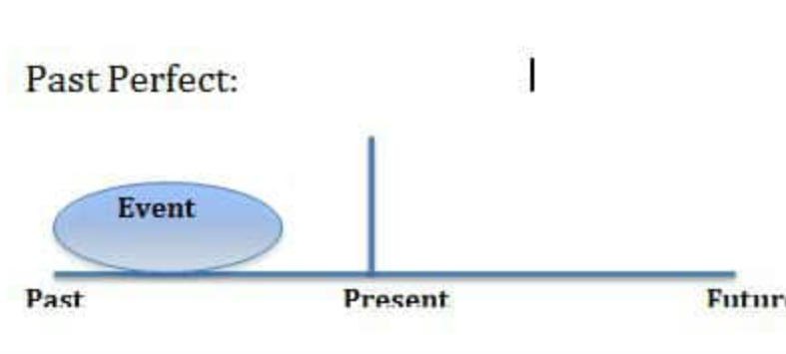

Retrieved from: <https://englishlive.ef.com/blog/language-lab/english-grammar-help-present-perfect-and-past-perfect/>

EXERCISES