|  |  |  |  |  |
| --- | --- | --- | --- | --- |
| 903 semana del 11 al 14 de mayo | 1 | 2 | 3 | observación |
|  | Bloque 1  Mayo 14 | BLOQUE 3 MAYO13 | Participacion  Mayo14 |  |
| ACOSTA TIQUE JUAN DAVID | **X** | **X** |  |  |
| ARANGO LAGUNA JOHAN ANDRES | **NA** | **X** |  |  |
| ARTEAGA GUZMAN CINDY MICHELLE | **X** | **X** |  |  |
| BARBOSA ACOSTA EMMILY ROCIO | **X** | **X** |  |  |
| BENAVIDES RINCON BRAYAN STEVEN | **X** | **X** |  |  |
| BERNAL SERNA JUAN PABLO | **X** | **X** |  |  |
| BERNAL SERNA KEVIN DANIEL | **X** | **X** |  |  |
| CAPERA ORTIZ NICOLE FERNANDA | **X** | **X** | **+** |  |
| CARDONA CRUZ BRAYAN ESTIVEN | **X** | **X** |  |  |
| ESPINOSA MUÑOZ NIKOL STEPHANY | **X** | **X** | **+** |  |
| GIRALDO PEÑUELA JUAN DAVID | **X** | **X** |  |  |
| GOMEZ LOPERA JHON ESTEBAN | **X** | **X** |  |  |
| GOMEZ PERDOMO YVONNE SABARY | **X** | **X** | **+** |  |
| GONZALEZ TORRES MICHAEL STIVEN | **X** | **X** |  |  |
| HOMEZ ZAMBRANO JOSEPH CAMILO | **X** | **X** |  |  |
| LEAL YAÑEZ VAMSI DANA | **X** | **X** |  |  |
| LEYVA SIERRA KERYM DARIANA | **X** | **X** |  |  |
| LOZANO FLOREZ LAURA VALENTINA | **NA** | **NA** |  |  |
| MALO SIERRA WILLIAM ANDRES | **X** | **X** |  |  |
| MORA DEVIES SANTIAGO | **X** | **X** |  |  |
| MUÑOZ DIAZ JUAN ESTEBAN | **X** | **X** |  |  |
| OSPINA GALINDO ASHLEE MARIANA | **X** | **X** |  |  |
| OVIEDO BAUTISTA NATAN SANTIAGO | **X** | **X** | **+** |  |
| OZUNA CHIMA BRAYAN | **X** | **X** |  |  |
| PARRA MEDINA JUAN SEBASTIAN | **X** | **NA** |  |  |
| PEÑA MONTEALEGRE CRISTIAN ANDRES | **X** | **X** | **+** |  |
| PIZZA SERRATO CATALINA | **X** | **X** |  |  |
| QUEVEDO BONILLA SEBASTIAN ALEJANDRO DE JESUS | **X** | **X** |  |  |
| RAMIREZ ALVAREZ MARIA LISETH | **X** | **X** |  |  |
| RAMIREZ GORDILLO DIEGO MAURICIO | **X** | **X** |  |  |
| RAMIREZ OLMOS DAKOTA | **X** | **X** |  |  |
| RIVERA USMA JOHAN STIVEN | **X** | **X** |  |  |
| RODRIGUEZ FARFAN ADEL SANTIAGO | **X** | **X** |  |  |
| VALERO RODRIGUEZ SHAKIRA | **X** | **X** |  |  |
| VARON MARIN SANTIAGO ANDREY | **X** | **X** |  |  |
| VASQUEZ PEÑA JUAN SEBASTIAN | **X** | **X** |  |  |

xx

xx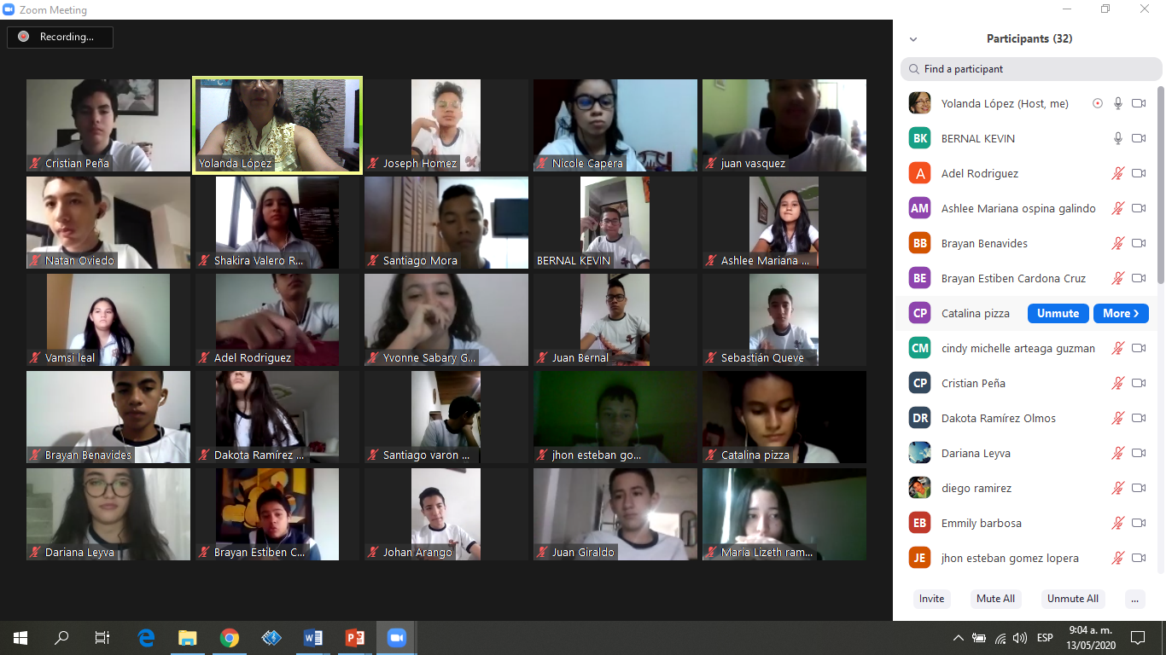

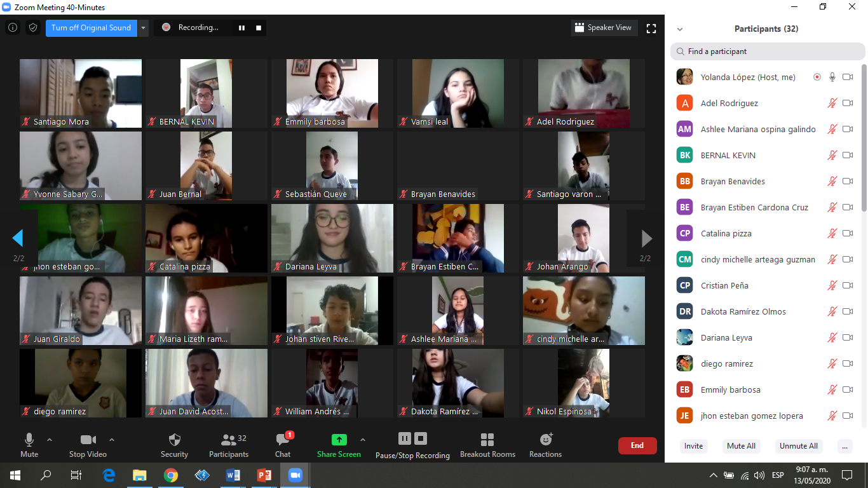

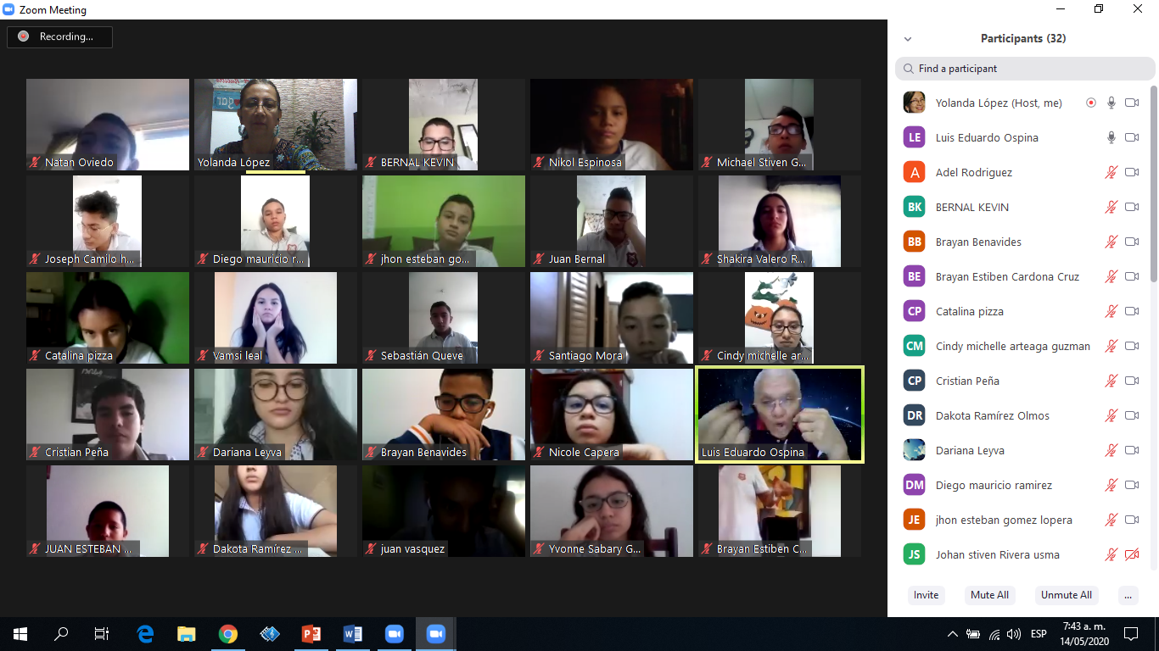

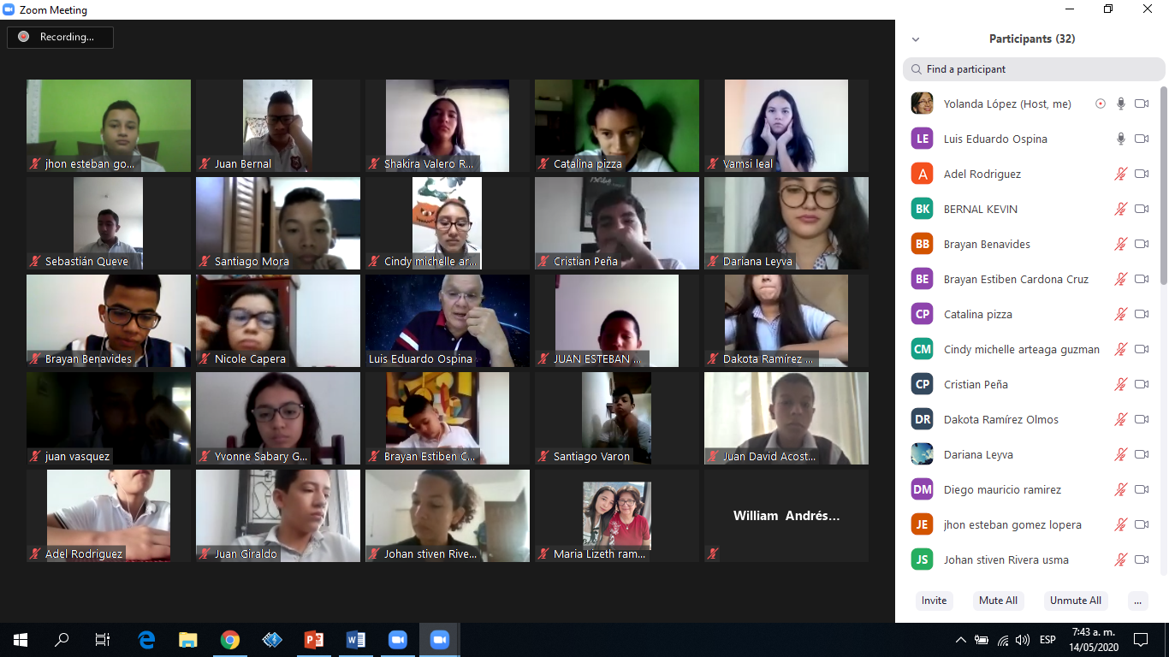

|  |  |  |  |  |
| --- | --- | --- | --- | --- |
| 903 semana del 18 al 22 de mayo | Día 1  Lunes bloque 2 |  | 3 | observación |
|  |  |  |  |  |
| ACOSTA TIQUE JUAN DAVID |  |  |  |  |
| ARANGO LAGUNA JOHAN ANDRES |  |  |  |  |
| ARTEAGA GUZMAN CINDY MICHELLE |  |  |  |  |
| BARBOSA ACOSTA EMMILY ROCIO |  |  |  |  |
| BENAVIDES RINCON BRAYAN STEVEN |  |  |  |  |
| BERNAL SERNA JUAN PABLO |  |  |  |  |
| BERNAL SERNA KEVIN DANIEL |  |  |  |  |
| CAPERA ORTIZ NICOLE FERNANDA |  |  |  |  |
| CARDONA CRUZ BRAYAN ESTIVEN |  |  |  |  |
| ESPINOSA MUÑOZ NIKOL STEPHANY |  |  |  |  |
| GIRALDO PEÑUELA JUAN DAVID |  |  |  |  |
| GOMEZ LOPERA JHON ESTEBAN |  |  |  |  |
| GOMEZ PERDOMO YVONNE SABARY |  |  |  |  |
| GONZALEZ TORRES MICHAEL STIVEN |  |  |  |  |
| HOMEZ ZAMBRANO JOSEPH CAMILO |  |  |  |  |
| LEAL YAÑEZ VAMSI DANA |  |  |  |  |
| LEYVA SIERRA KERYM DARIANA |  |  |  |  |
| LOZANO FLOREZ LAURA VALENTINA |  |  |  |  |
| MALO SIERRA WILLIAM ANDRES |  |  |  |  |
| MORA DEVIES SANTIAGO |  |  |  |  |
| MUÑOZ DIAZ JUAN ESTEBAN |  |  |  |  |
| OSPINA GALINDO ASHLEE MARIANA |  |  |  |  |
| OVIEDO BAUTISTA NATAN SANTIAGO |  |  |  |  |
| OZUNA CHIMA BRAYAN |  |  |  |  |
| PARRA MEDINA JUAN SEBASTIAN |  |  |  |  |
| PEÑA MONTEALEGRE CRISTIAN ANDRES |  |  |  |  |
| PIZZA SERRATO CATALINA |  |  |  |  |
| QUEVEDO BONILLA SEBASTIAN ALEJANDRO DE JESUS |  |  |  |  |
| RAMIREZ ALVAREZ MARIA LISETH |  |  |  |  |
| RAMIREZ GORDILLO DIEGO MAURICIO |  |  |  |  |
| RAMIREZ OLMOS DAKOTA |  |  |  |  |
| RIVERA USMA JOHAN STIVEN |  |  |  |  |
| RODRIGUEZ FARFAN ADEL SANTIAGO |  |  |  |  |
| VALERO RODRIGUEZ SHAKIRA |  |  |  |  |