[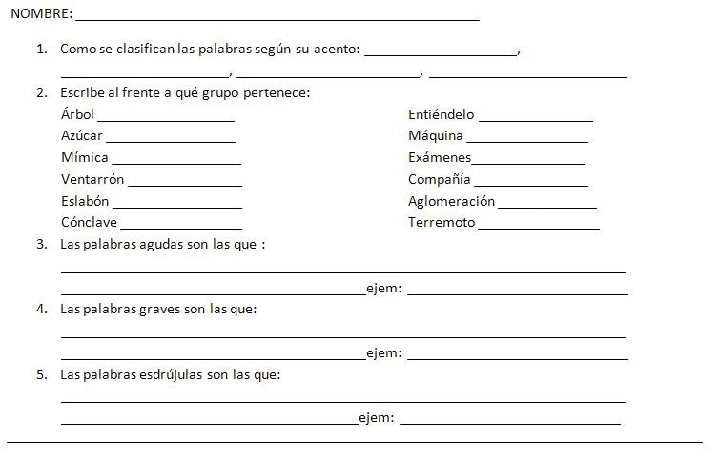](https://sites.google.com/site/lasilabagrado4/home/Dibujo.JPG?attredirects=0)