[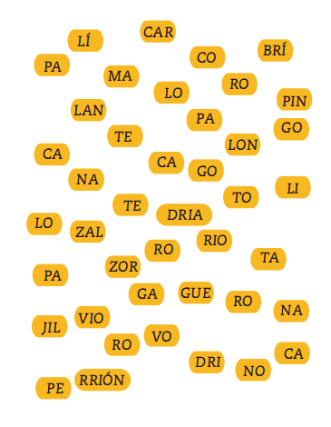](https://sites.google.com/site/lasilabagrado4/home/j1.png?attredirects=0)