**SAGRADA FAMILIA SCHOOL**

**LESSON PLAN LUZDARY CARDENAS AND JULIETA COVALEDA**



1. **TOPIC**: dba number 2 and dba number 5 (Health Prevention; how to live in harmony: mental and physical health)
2. PURPOSE:

**Communicative Purpose:** to develop linguistic and communicative competences and skills: listening, reading, speaking and writing.

**Grammar Purpose:**

Connectors: the student takes into account relationships of comparison, contrast and addition, among others.

Comparative forms: find differences between **more than and _er than**

**Future tense: Will, Wont.**

Process:

* Use adjectives, connectors and comparative forms
* Exchange information about academic topics
* Write about values and health.

1. **MOTIVATION**

Students listen and watch some videos about the topics: values and health prevention)

**HEALTHY HABITS (REMEMBER THIS BEAUTIFUL SONGS)**

<https://www.youtube.com/watch?v=ywP0wXaABiQ>

Habits are very hard to break

Have healthy habits for that sake

If healthy habits are in place

Your life will be better in many ways

Wake up early, wake up early

Enjoy the beautiful morning clearly

Brush your teeth and wash your face

Your day now starts with full of grace

Wish your father, wish your mother

Wish your little brother and sister

Wish your friends and everyone – now

You are a very special one

Make sure you have a healthy breakfast

It will give you the energy to move fast

Having fruits and vegetables are so cool

Now let’s make it on time to school.

Now let’s recall the healthy habits

Wake up early, early, early, early

Brush your teeth, brush, brush, brush

Wash your face, wash, wash, wash

Wish your family, wish, wish, wish

Have a healthy breakfast, eat, eat, eat

Go to school in time, go, go, go

<https://www.youtube.com/watch?v=wrF1e6boNbc>

* Take notes from the videos about the principal topic
* Produce texts or a short poster making recommendations or suggestions related to health care.
* Read the poster **at zoom first meeting (homework)**

1. **EXPLANATION**

* First part: warming up

Answer the following questions

a. What are the most common health problems in Colombia?

b. What are the principal good habits to be healthy?

c. what are the bad habits in health. what are the principal advice?

d. what are your responsibilities with yourself to become a healthy person?

e. In this time students refers: concepts, physical and mental diseases, characteristics, people, professions, parts of the body, documents, problems and places where people can get this service.

more than--- er than…( BUSCAR VIDEOS )

f. Teacher asks about health in America, students give many words, sentences and previous knowledge about health.

g. Students look for information and make comparisons with Europe health service.

.

* Second part: reading aloud (reading comprehension: dba 2: Chikungunya)

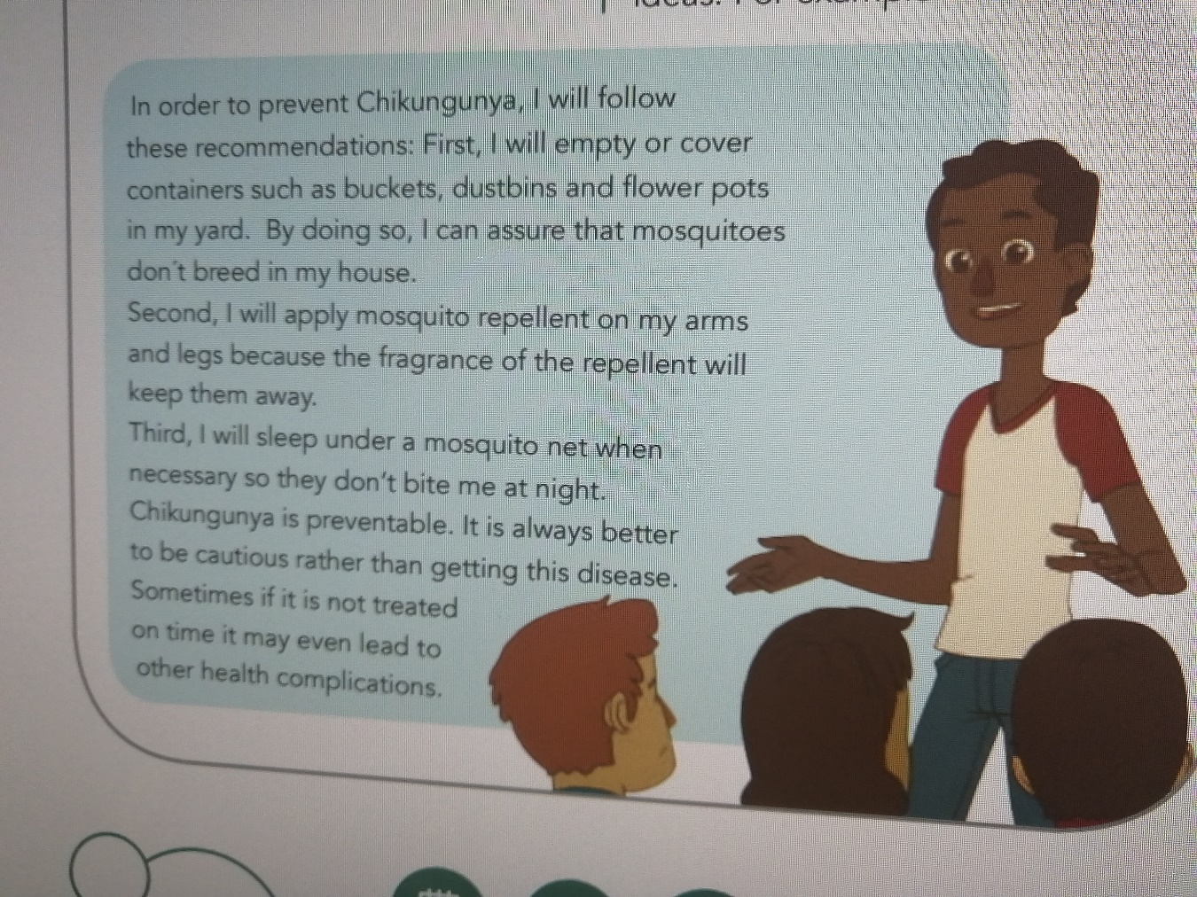

Teacher reads the text aloud, they made questions and answers each other about the text. Teacher makes corrections on the pronunciation. Then, the students read the text aloud too. After, they underline the unknown words in order to get better comprehension

* speaking

Later by pairs, they make written and oral questions about the content of text. Teacher asks the characteristics of an informative text, and its structure. That is the opportunity to explain this topic, students make comparisons. They recognize: tittle, introduction, development of ideas and conclusion.

* Writing as a process

***Plan:***in order to begin writing process, you have to make a conceptual map about chikungunya disease.

***Write***

Write a short informative text using information of the map and using connectors studied.

***Review***

some of these texts will be analyse in class.

***Edition***

You have to finish your text.

1. PRACTICE: EJERCITACIÓN

You have to:

* Read or watch a text about 19 covit virus.
* Share information in an oral presentation.
* Make comparisons, for example with other diseases. you have to make comparisons using connectors and especial expressions to begin a text, to add, to opposite, to contrast and to finish a text.

1. EVALUATION: Read this test by pairs. Make a dialog. 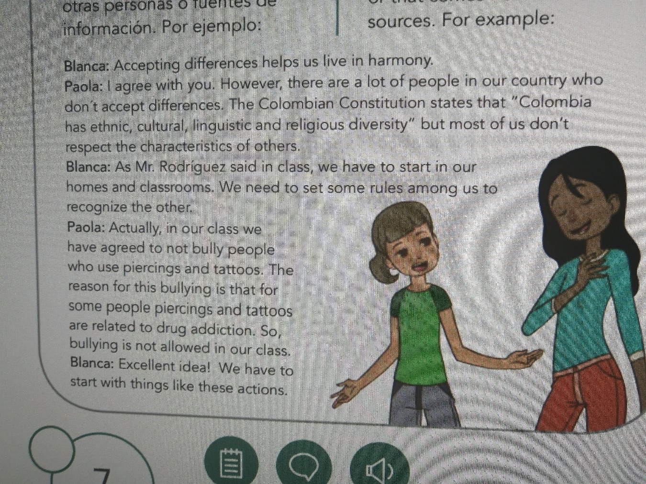

FORUM: How to live healthy and in harmony? Think about psychological and physical healthy people.