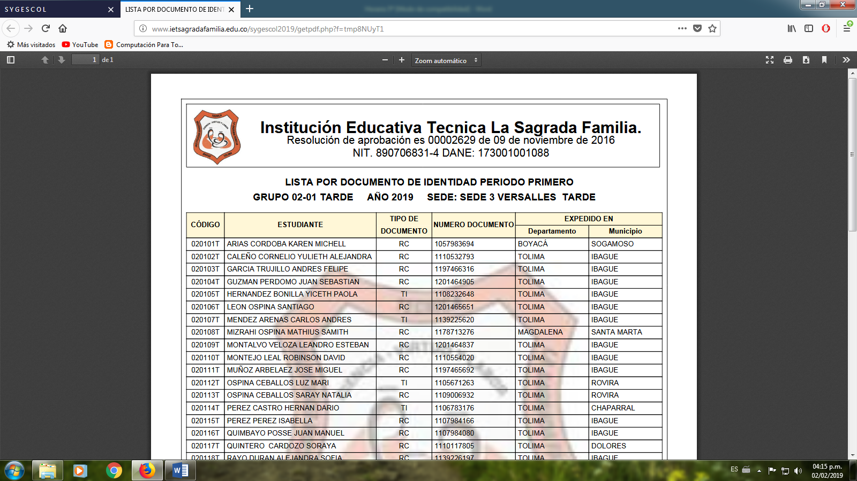INSTITUCIÓN EDUCATIVA TÉCNICA “LA SAGRADA FAMILIA”

SEDE VERSALLES

TALLER DE INGLÉS

GRADO 5º

2020

**EJERCICIOS**

1. Complete las oraciones con las formas del verbo to be (am, is, are)

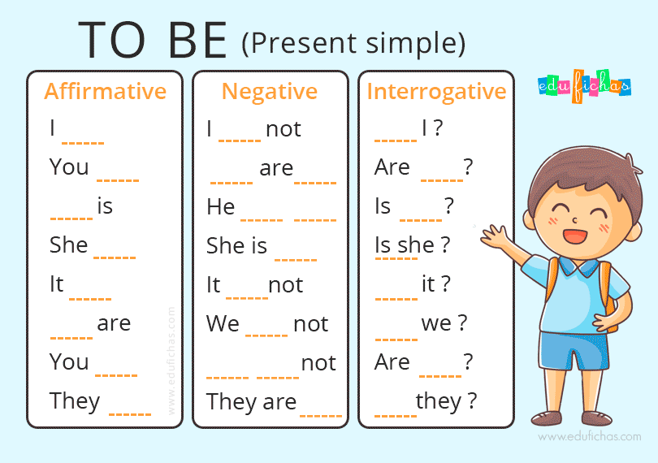

1. Escribe en forma negativa e interrogativa las siguientes oraciones

|  |  |  |
| --- | --- | --- |
| AFFIRMATIVE | INTERROGATIVE | NEGATIVE |
| Mark is a student |  |  |
| She is a fat |  |  |
| It is a ball |  |  |
| I am in the park |  |  |
| They are friends |  |  |
| He is a doctor |  |  |
| We are in the hospital |  |  |

1. Completa las frases, tenga en cuenta los ejemplos.

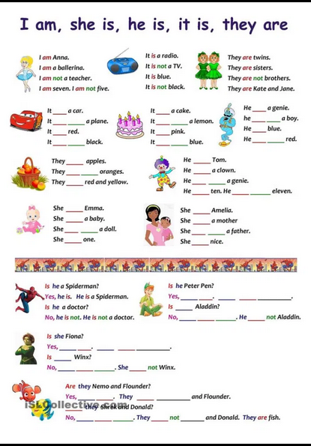

**TAREA**

1. Observa las imágenes y responde las preguntas

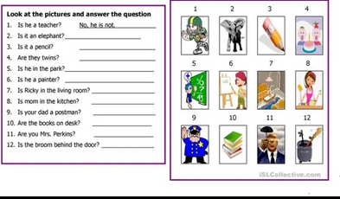

1. Is he a teacher? _____No, he is not_________
2. Is it an elephant?_____Yes, it is an elephant______
3. Is it a pencil? _______________________________
4. Are they twins? _______________________________
5. Is he in the park ? _____________________________
6. Is he a painter? _______________________________
7. Is Ricky in the living room? __________________________
8. Is mom in the kitchen? __________________________________
9. Is your dad a postman?__________________________________
10. Are the books on desk? ___________________________________
11. Are you Mrs. Perkins? _____________________________________
12. Is the broom behind the door?______________________________

2. Escoge la respuesta correcta teniendo en cuenta las imágenes del recuadro

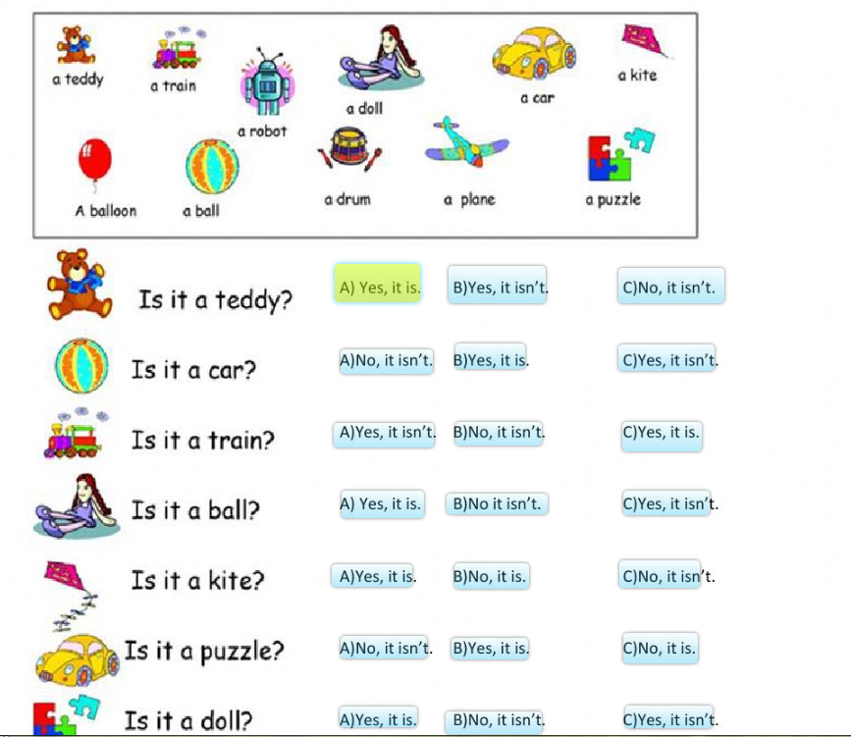



[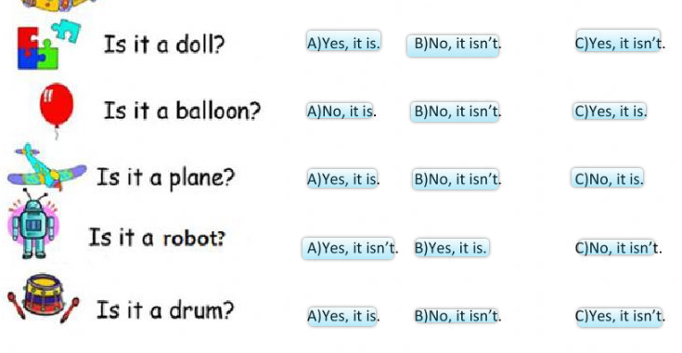](https://es.liveworksheets.com/du1736ue)

3. Completa el siguiente cuadro

|  |  |  |
| --- | --- | --- |
| Affirmative | Interrogative | Negative |
| He is tall | Is he tall ? | He is not tall |
|  |  | He is not sad |
|  | Is he Young? |  |
| He is happy |  |  |
|  |  | She is not sad |
|  | Are they old? |  |
| They are sad |  |  |
|  |  | It is not thin |
|  | Is he short? |  |
| It is fat |  |  |