EVALUACIÒN DE INGLÈS

Name: ______________________________Date: __________

1. What color is it ? ( ¿Qué color es ? )

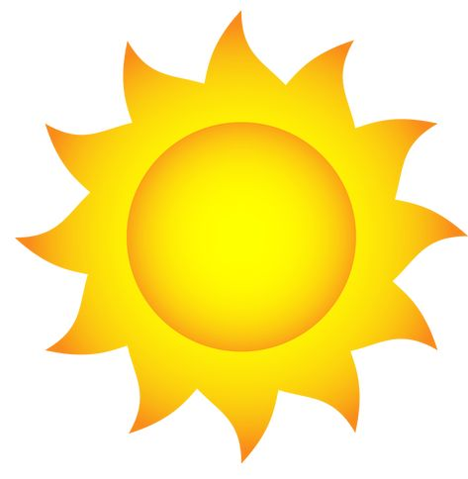

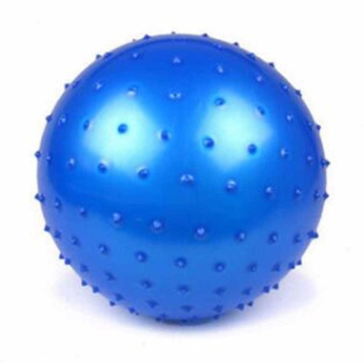 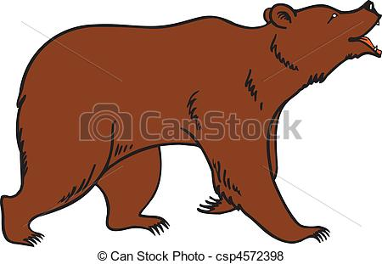 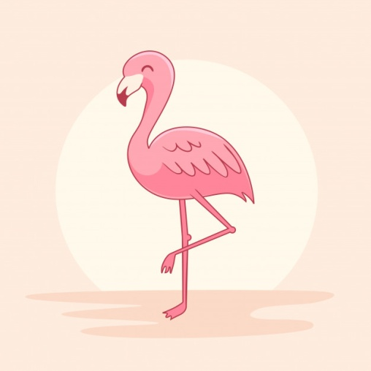 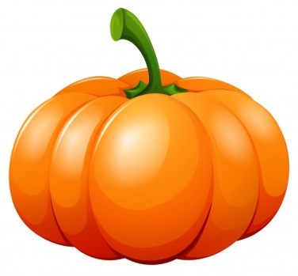

1. It is ___________ 2. It`s ____________ 3. It is _____________ 4. It`s _______________

5. It is ___________ 6. It`s _____________ 7. It is _____________ 8. It`s _______________

1. What fruit is this? ( ¿Què fruta es esta? )

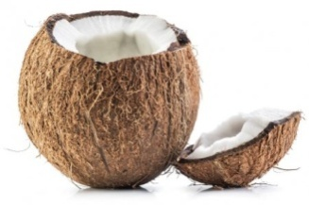 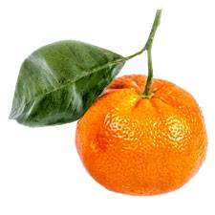 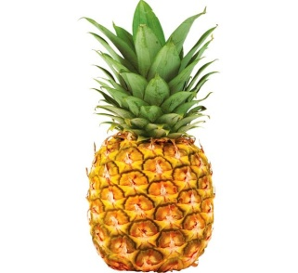

It is a _________ It is a _________ It is a _________

1. Look, read and circle. (Mira, lee y rodea).

Is this a rhino? Is this a tiger? Is this a caw?

 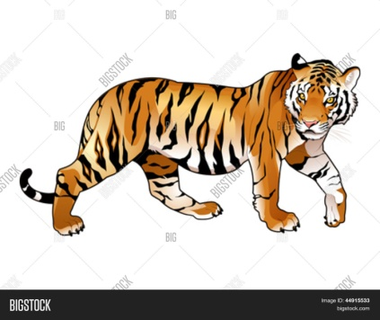 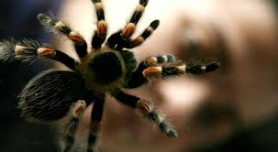

* Yes, it is -Yes, it is - Yes, it is
* No, it isn`t - No, it is not - No, it is not

1. Traduzco:

Orange watermelon lemon peach pear cherry strawberry

fish turtle rabitt spider bird snake hen rooster bat rhino