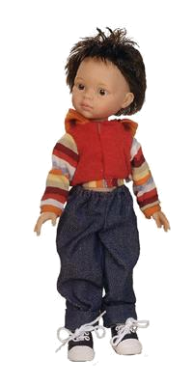







8. Write a short story about your friend:

Name: Karen
Surname: Ortiz
Age: 9
Job: student
Nationality: Colombian
City: Ibagué
Hobby: reading

VERB TO BE
1. Fill in the correct form of the verb to be:
1. They ____ friends.
2. Sam ____ at home now.
3. Liz and Kate ____ at school.
4. Tim ____ eleven years old.
5. Dan ____ a student.
6. You ____ at the English lesson.
7. They ____ from London.
8. I ____ in the park.
9. She ___ a doctor.
3. Correct the mistakes:
1. Liz are ill.
2. Ben am my best friend.
3. Liz and Kate is sisters.
4. Tim and Bob is at home.
5. Dogs is animals.
6. Nick are from London.
7. Bill am eleven now.
8. They is very lazy.
9. We am in the hall.

2. Fill in am not, isn’t, aren’t:
1. He____ a pilot.
2. You ____ a boy.
3. She ____ a painter.
4. It ____ a cat.
5. I ____ at the lesson.
6. She ____ ten.
7. He ____ in the museum.
8. You ____ at school.
9. I ____ lazy.

5. Answer about yourself:
1. Are you a student?
2. Are you eleven?
3. How old are you?
4. Are from Paris?
5. Are you from France?
6. What country are you from?
7. Are you a sportsman?
8. What is your home address?
9. What is your phone number?

6. Ask questions and give short form answers:
1. ___ he a doctor? Yes, he ___ .
2. ___ you in the classroom? No. we ____.
3. ___ they friends? Yes, they ____ .
4. ___ Liz at home? No, she _____ .
5. ___ you singers? Yes, we _____ .
6. ___ that Nick? No, he _____ .
7. ___ Bob from London? Yes, he _____ .
8. ___ you ten? Yes, I _____ .
9. ___ it a cat? Yes, it _____ .
7. Fill in am, is, are:

Hi! My name ____ John.
I ___ 10 years old. I ___
a student. I ___ a good boy.
I ___ a sportsman.
My best friends ___ Nick
and Charlie. They ___
students too. We ___ always
together. They ___ good
friends.

Attention:

I am

He
She is
It

We
You are
They
4. Fill in the negative form of the verb to be:
1. They ______ students.
2. Sam _____ in the gym.
3. Kate ______ twelve years old.
4. We ______ in London.
5. The dog _____ under the table.
6. I _____ in the museum.
7. You _____ twelve years old.
8. She _____ a dancer.
9. We _____ friends.

