Name: ________________________________________________________________


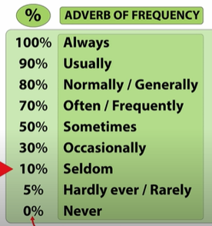

Read the following sentences:
- Josh ALWAYS gets up at 7 o´clock. 5. I NEVER go to school by bus.
- He is NEVER late for school. 6. Does he ALWAYS wear a suit?
- My parents don’t USUALLY work on Saturdays. 7. He HARDLY EVERY goes to the cinema.
- Do you SOMETIMES take a nap on Sundays?
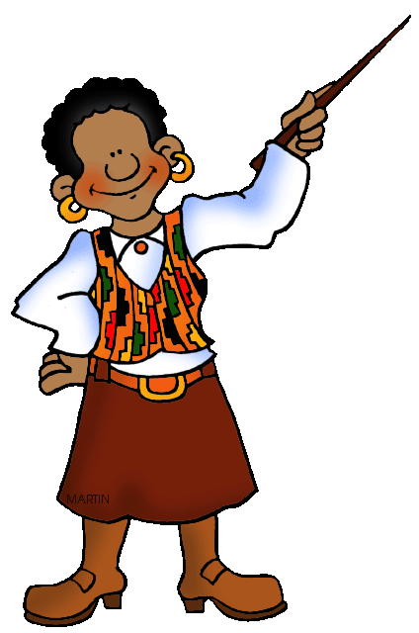
Adverbs of frequency are used:
- before the main verb BUT after the verb “to be”
- between the auxiliary verb and main verb in negative sentences
- after the subject in interrogative sentences

SOMETIMES can be used in the beginning of a sentence!

Indicate in the sentences and insert the adverb of frequency in the correct place.
EX They ** play football on Sundays after lunch. (sometimes)
2. She is at home in the evening. (never)
3. Do you go to the theatre? (often)

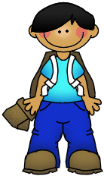
4. We don’t travel during the summer holidays. (usually)
5. Henry goes to bed late. (hardly ever)
6. Does the dog sleep in the afternoon? (sometimes)
7. The children watch TV after school. (always)
8. Billy and his brother have dinner with their family. (always)

Answer these questions about yourself. Use frequency adverbs
1. How often do you go swimming? _________________________________________________
2. How often do you play football? __________________________________________________
3. How often do you go running? ___________________________________________________
4. How often do you play tennis? ___________________________________________________
5. How often do you play basketball? ________________________________________________
6. How often do you go to cinema? __________________________________________________


Put the words in the correct order:
1. go / you / restaurant / often / a / do / how / to / ?
__________________________________________________________________________________
2. late / is / she / sometimes __________________________________________________________________________________
3. you / out / how / in / do / evenings / often / go / the / ?
__________________________________________________________________________________
4. get / I / early / on / never / Saturdays / up.
__________________________________________________________________________________
5. at / o’clock / usually / breakfast / have / I / nine
__________________________________________________________________________________
6. in / often / go / pool / I / the / morning / to / the
__________________________________________________________________________________
7. listen / afternoon / I / music / to / the / in / sometimes
__________________________________________________________________________________
8. in / television / I / evening / always / the / watch.
__________________________________________________________________________________
9. do / ? / how / go / school / often / you / to.
__________________________________________________________________________________
10. your / does / mother / to / gym / ? / usually / go / the.
____________________________________________________________________


Write a short composition about what things you do at the weekend. It is very important to use frequency adverbs:
_________________________________________________________________________________________________________________________________________________________________________________________________________________________________________________________________________________________________________________________________________________________________________________________________________________________________________________________________________________________________________________________________________________________________________________________________________________________________________________________________________________________________________________________________________________________________________________________________________________________________________________________________________________________________________________________________________________________________________________________________________________________________________________________________________________________________________________________________________________

