**MOTIVACIÓN**

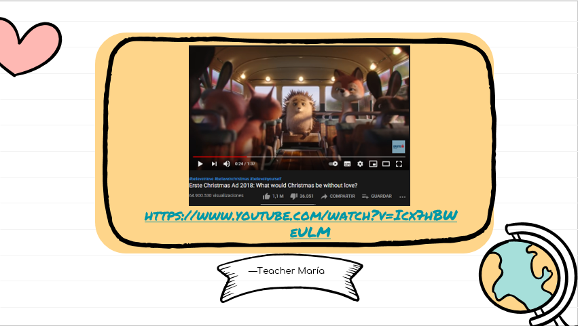

**GO TO THE LINK, WATCH THE VIDEO AND ANSWER THE QUESTIONS** <https://www.youtube.com/watch?v=Icx7hBWeULM>

1. What is the situation of the video?

2. what are the characters?

3. How do you think the main character is feeling?

4. What was the solution all the animals gave to the situation?

5. What did you learn from the video?

**EXPLICACIÓN**

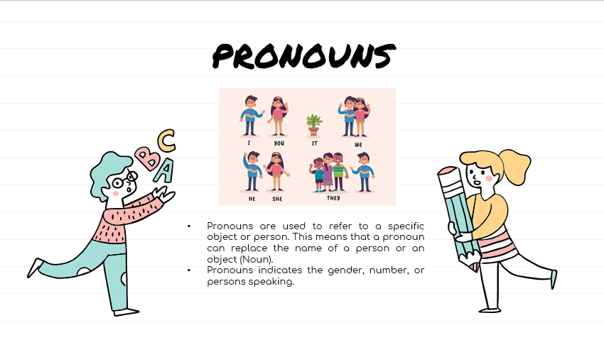

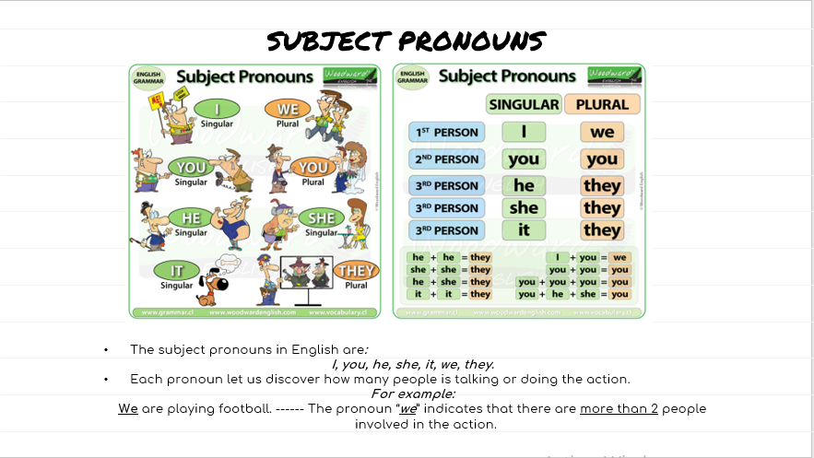

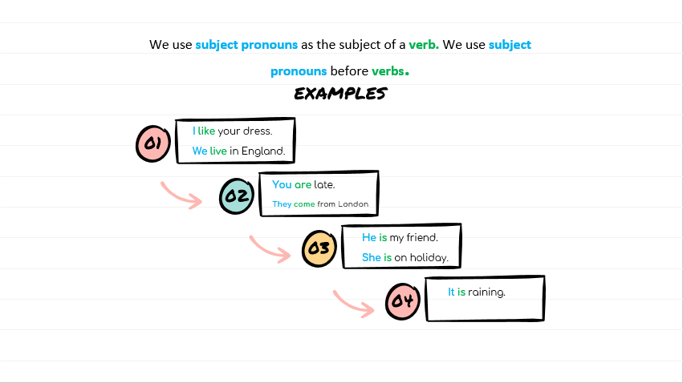

**EXERCISE 1**

1. Match the images in the circle with the correct subject pronoun.

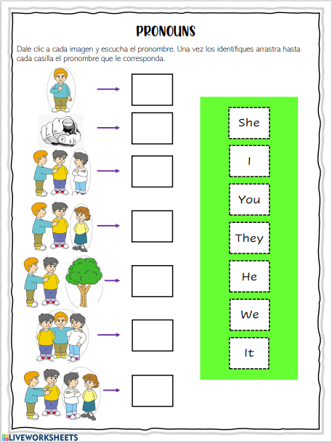

**EXERCISE 2**

In order to have clear the third person, please look at the images and write the correct option (**HE-SHE-IT**).

**HE-SHE-IT**

|  |  |
| --- | --- |
|  |  |
|  |  |
|  |  |

**EXERCISE 3**

Select what are the names (nouns) that we can replace for that pronoun. Write down on the notebook the ones that are possible.

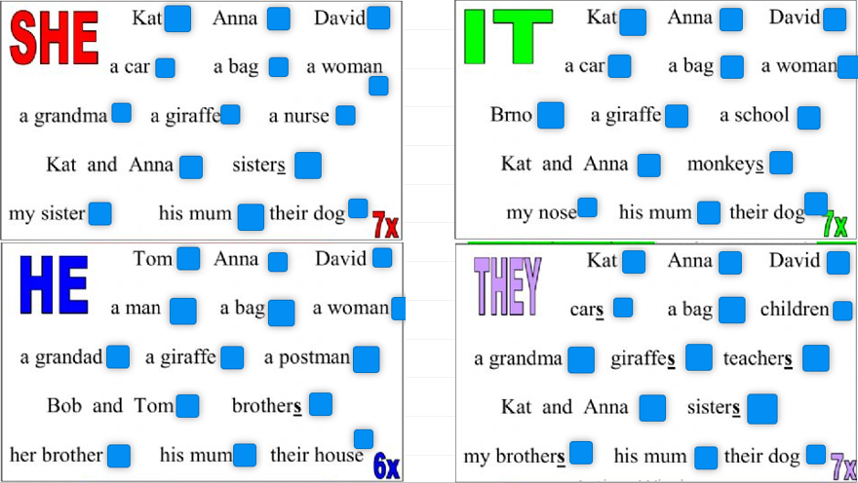

**EVALUATION**

Complete the sentences with the correct subject pronoun. **This exercise can be found in the Evaluation Box.**

