READING COMPREHENSION

1. Read the following text and answer the questions.

**Note: Para los estudiantes que estuvieron en clase y ya tienen nota, no hay necesidad de que suban las respuestas de nuevo.**

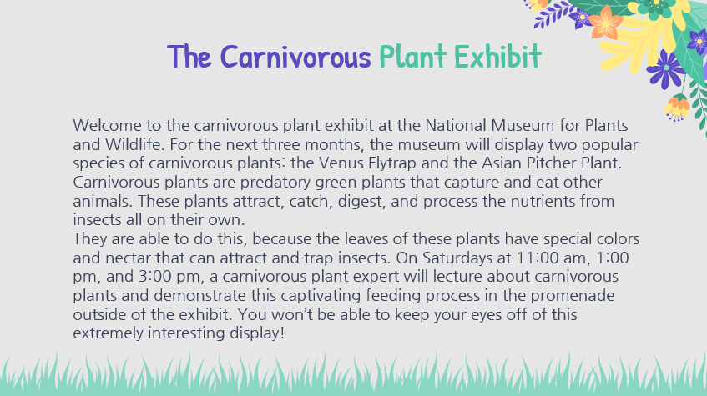





**QUESTIONS:**

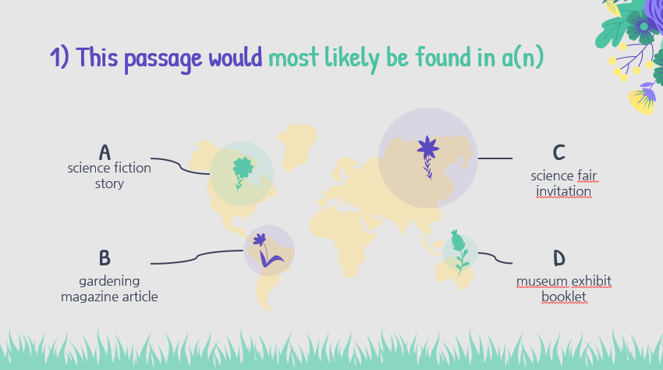

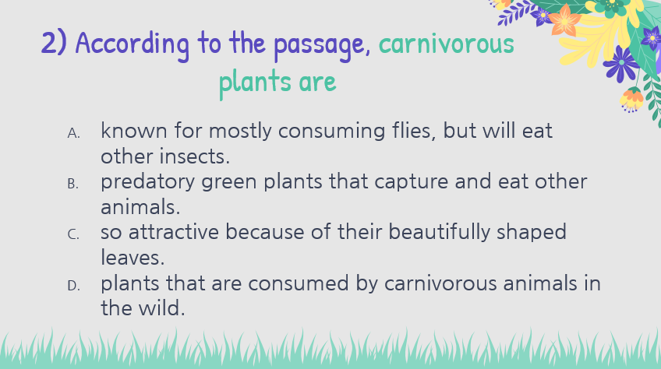

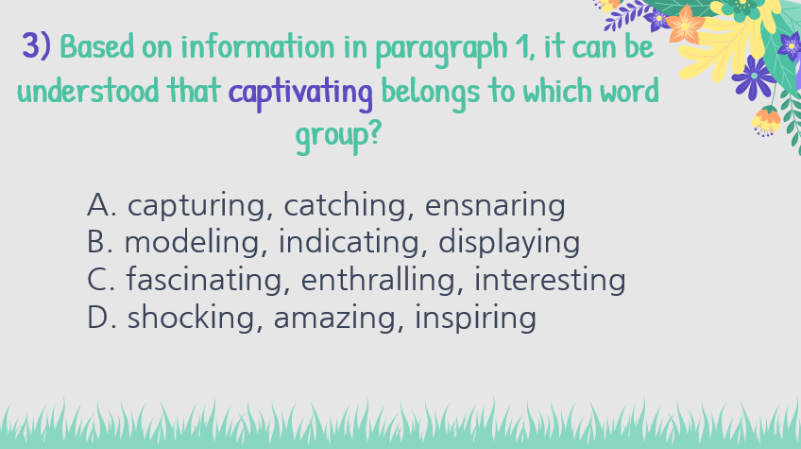

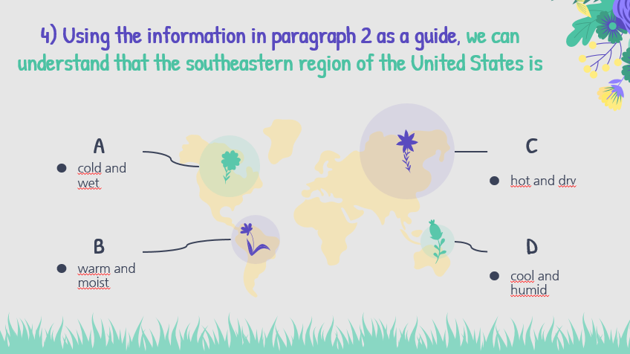

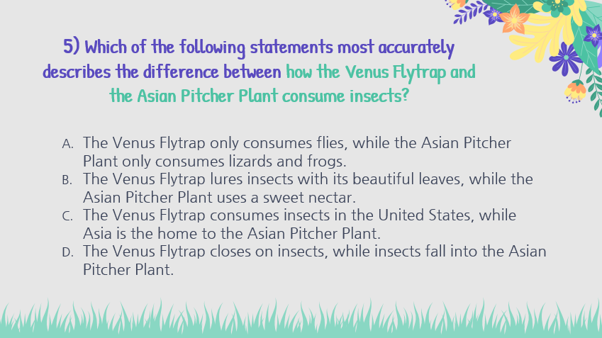

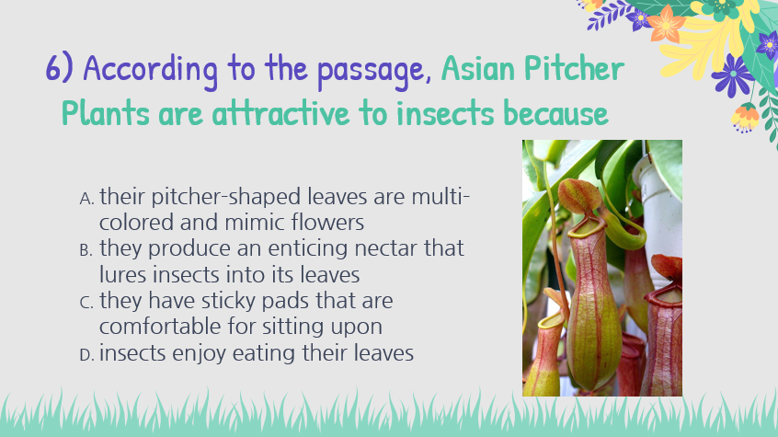

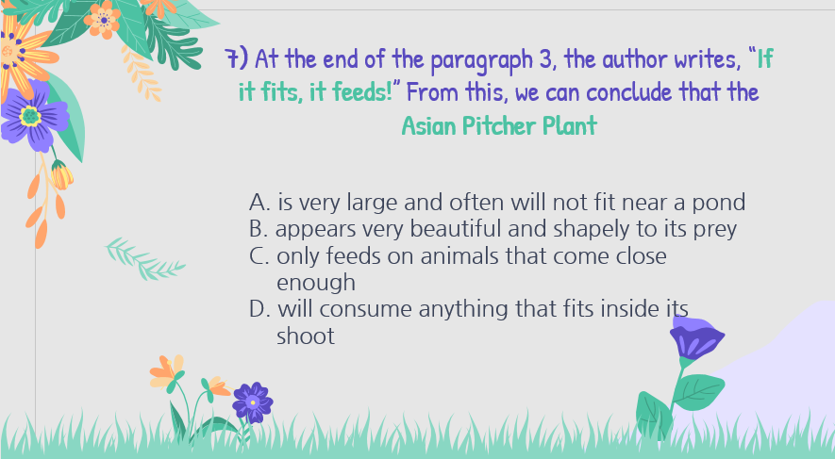

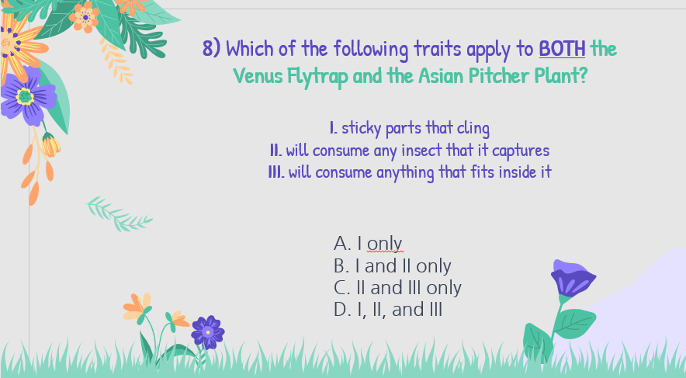

**GIVING MY OPINION**

**Useful chart:** In the following chart, you will find useful expressions you can use when giving your point of view regarding a specific topic. Please write the phrases on your notebook.

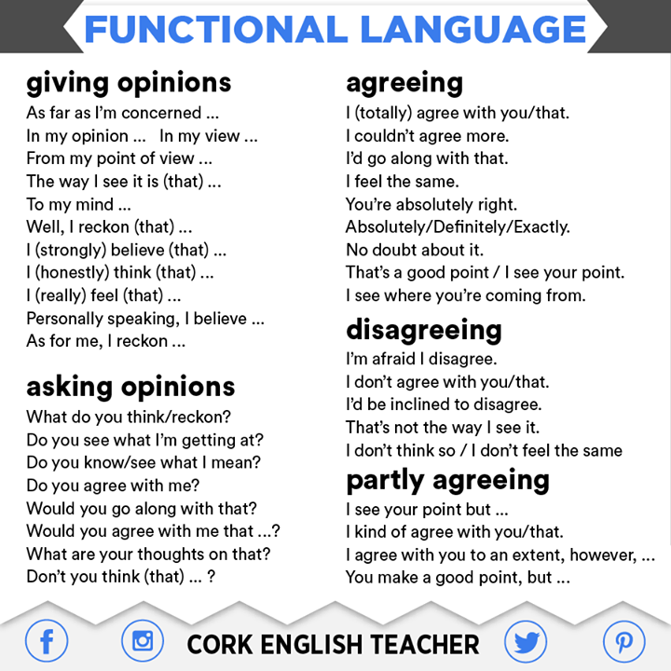

1. BEFORE THE VIDEO: Answer the following questions.

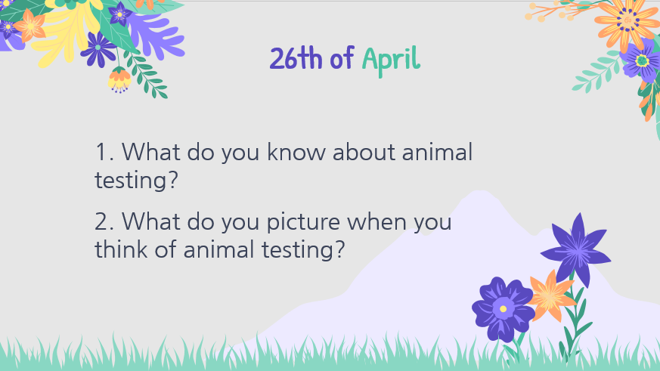

1. Watch the video “Save Ralph” in the following link <https://www.youtube.com/watch?v=G393z8s8nFY>
2. Now, select one of the words that appear in the chart and answer the question that belong to that word.

**The text should include:**

* Minimum 5 sentences.
* Minimum 5 phrases to express opinion.

