PLATAFORMAS DIGITALES

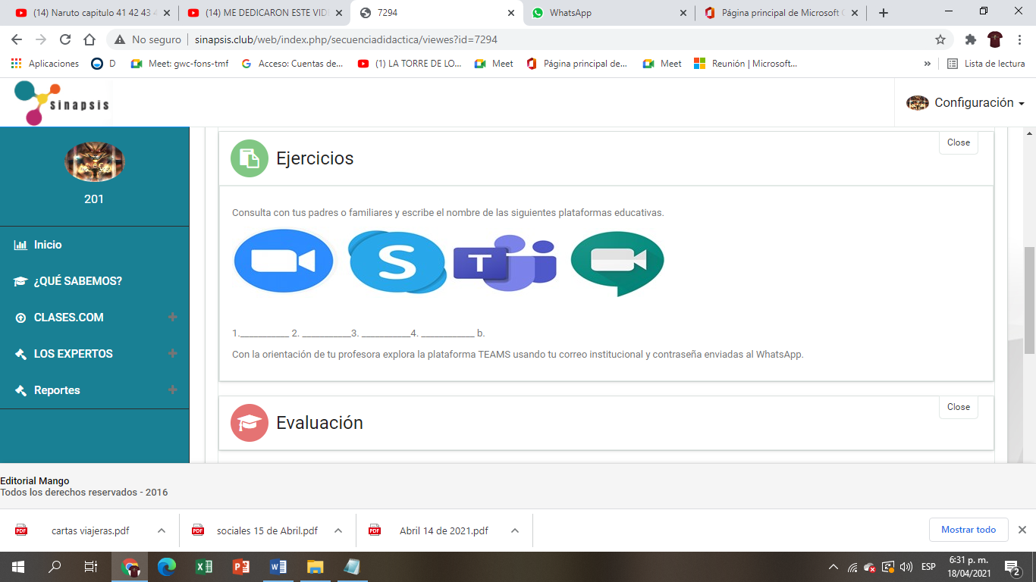

1. ZOOM
2. SHAREPOINT
3. TEAMS
4. MEET