Second world war

(1939-1945)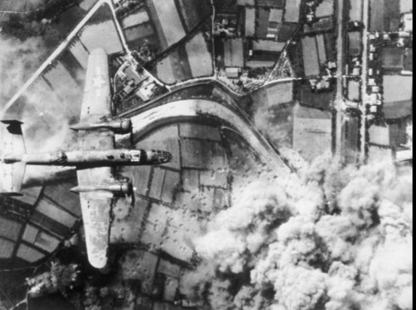

It was a global military conflicto that developed between 1939.and 1945.

I entered them, most of the nations of the world were involved, with more than one hundred million suldiers mobilized and a state of total war.

Main cause.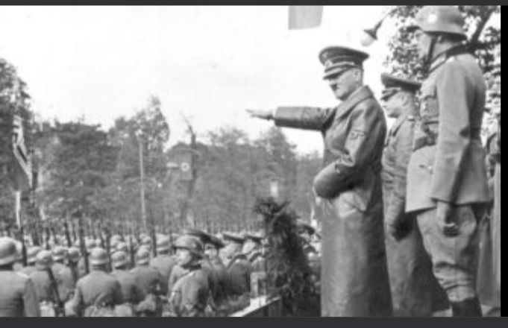

The ambition of Adolf Hitler (germany)

Benniito Mussolini (italy)

And Hirohito (japan)

For him economic and political dominance of the planet, wresting its colonies and semi-colonies from the allied Powers.

Where the great contenders devoted all their economic, military and scientific capacity to war.

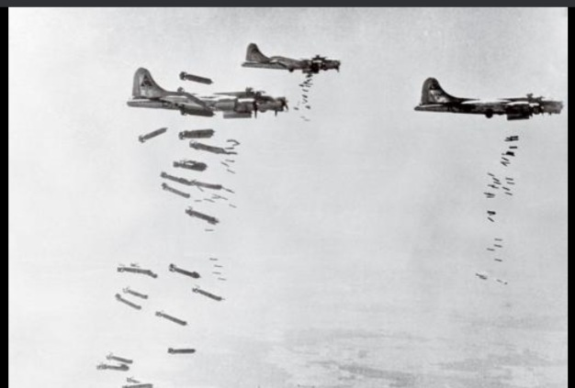In this war nuclear bombs were used for the only time.

.

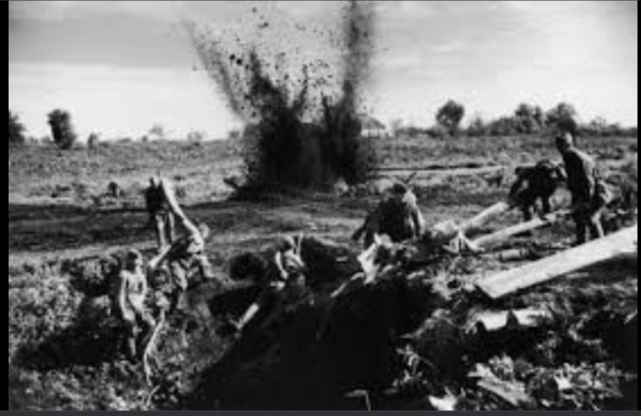

Intensive bombing of cities.

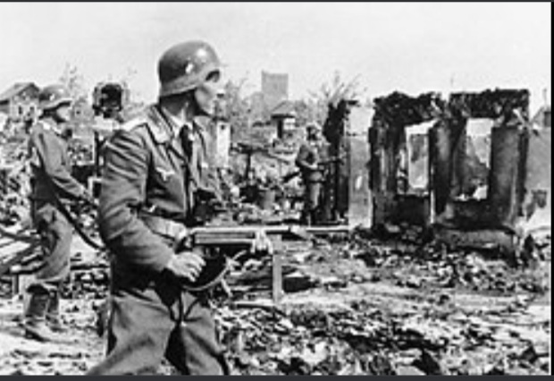

The second world war was the deadliest in history.

With a resulto of between 50 and 70 millions of victims 2% of the Word population lasted 6 years 1 day.

Consequences.

* Collapse of nazi germany.
* Fall of the japanese and italian empires.
* Creation of the united nations.
* Emergence of the united states and super `Powers.
* Beginning of cold war.
* Restart of civil war in china.
* Initiation of the decolinization process of Asia and africa.
* Korea división.