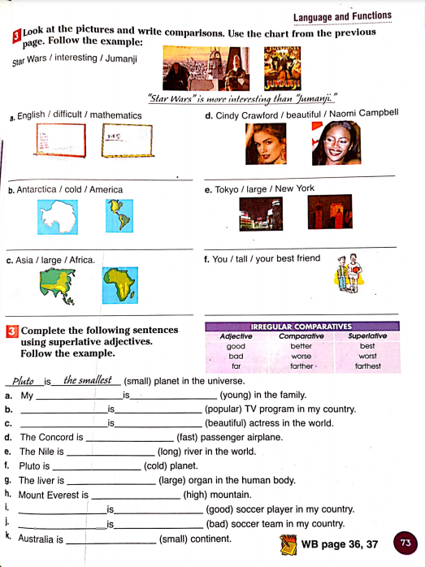

Tokyo is bigger than new york

You are taller than your best friend

Asia is bigger than africa

Antárctica is colder than amreica

English is more difficult what the mathematics

Cindy Crawford is more beautiful naomi champbell

smaller

The bad

nacional

montero

The good

The most high

The most large

colder

longer

faster

The most

Megan fox

The most

caracol

The youngest

sister

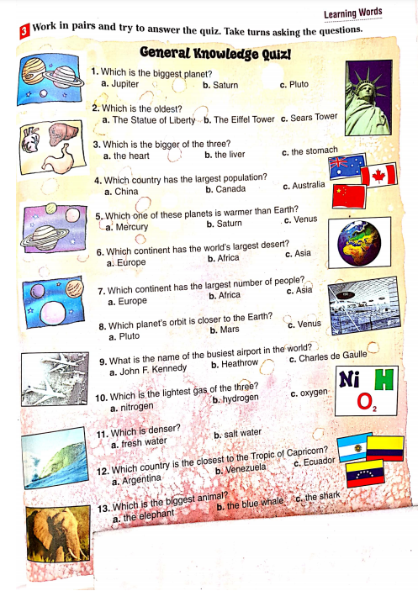m

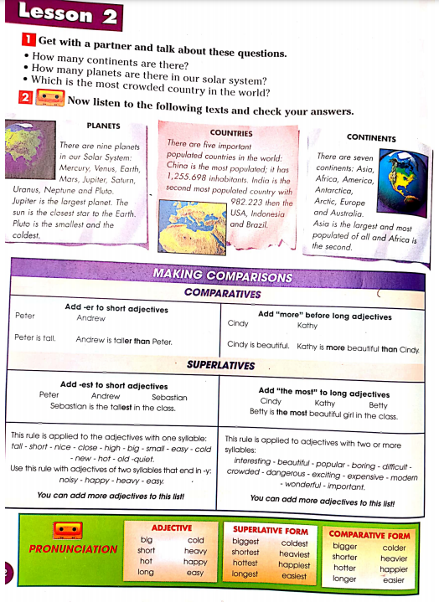

**RESPUESTAS/ANSWERS**

1. ¿HOW MANY CONTINENTS ARE THERE?

R/ THERE ARE SEVEN CONTINENTS.

¿HOW MANY PLANETS ARE THERE IN OUR SOLAR SYSTEM?

R/ THERE ARE NINE PLANETS IN OUR SOLAR.

¿WICH IS THE MOST CROWDED COUNTRY IN THE WORLD?

R/ CHINA IS THE MOST POPULATED.