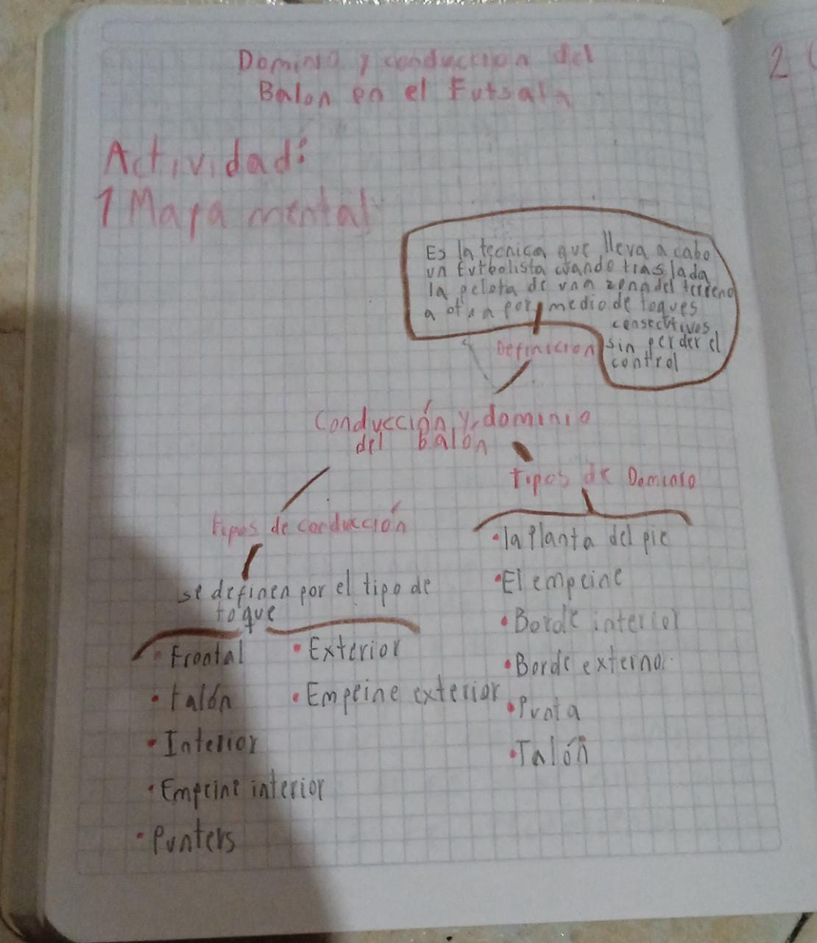

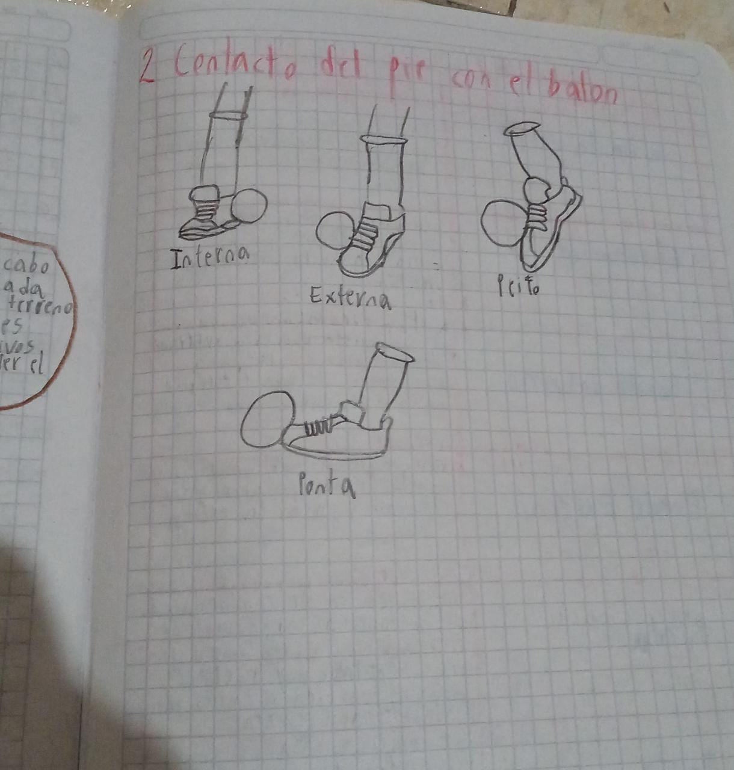

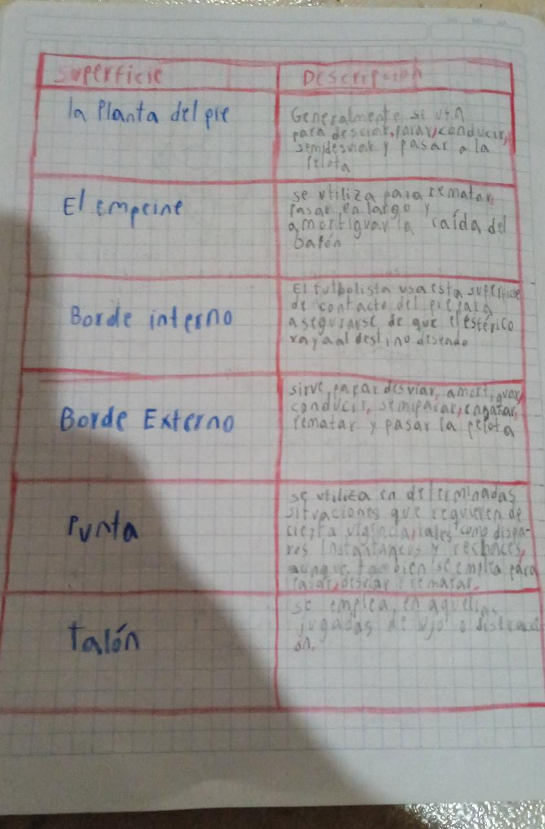

<https://drive.google.com/file/d/121Ypk2IItbm5a-DcWQKDjfz1G1sppCO4/view>