ENGLISH 20% 6º

Student’s name: _______________________________________ course: __________ date: _________________

Read the text. For questions 1-8, circle the correct answer (A,B, or C)

“Welcome to my home Page”

Hello! My name is Mary. I’m 12 years old. My mother and father are Ann and John. My brother is Tony and he is eight years old. His favorite color is blue. Sally is my sister and she in 20 years old. Sniffy is Sally’s cat. Sniffy is white and she´s six years old. Max is my dog. He is black and white. He is two years old. My favorite color is green.
That’s all about me and my Family. ¿What about you? Thanks for visiting

1. Mary is 10 years old
A. Right
B. Wrong
C. Doesn’t Say

2. Ann is Mary’s mother
A. Right
B. Wrong
C. Doesn’t Say

3. Tony is Mary’s father
A. Right
B. Wrong
C. Doesn’t Say

4. Max is a cat
A. Right
B. Wrong
C. Doesn’t Say

5. Mary’s dog is one year old
A. Right
B. Wrong
C. Doesn’t Say

6. Tony`s pet is a parrot
A. Right
B. Wrong
C. Doesn’t Say

7. Mary’s dog is black and white
A. Right
B. Wrong
C. Doesn’t Say

8. Mary’s favorite color is blue
A. Right
B. Wrong
C. Doesn’t Say

II. Choose the correct answer (A,B or C) to complete the dialogues

9. How are you?
A. What about you?
B. I’m ten
C. I’m fine, thanks

10. What’s your Last name?
A. John
B. My mother’s name is Anita
C. Simpson

11. How old are you?
A. She’s eight
B. You’re eight
C. I’m eight

12. Who’s he?
A. She’s my mother
B. He’s my father
C. They’re my brother and sister

13. What’s your first name?
A. Smith
B. Tony
C. 10

14. My name’s Susan Jone __________ to Bogotá city.
A. Pleased
B. Welcome
C. Fine

15. Where is your mother?
A. He’s in the class - room
B. She’s in the class - room
C. I’m in the class - room

16. Is the mouse under the table?
A. Yes, it’s
B. Yes, She’s
C. Yes, you’re

17. Fine, thanks
A. Hi, how are you?
B. How old are you?
C. Hi, who are you?

18. The shoes are ____________the bed
A. Under
B. In
C. on

19. The cat is ____________the house
A. Under
B. In
C. on

20. The apples are __________ the box
A. Under
B. In
C. on

ENGLISH 20% 8º

Student’s name: _______________________________________ course: __________ date: _________________

I choose the best option

1. __________ be there at four o’clock
A. We
B. We’ll
C. We’re

2. What time ______________ be back?
A. Will you
B. Are you
C. Will you

3. Look at the clouds. It __________________
A. Rains
B. Will rain
C. Is going to rain

4. When _______________ know the answer?
A. Will he
B. Will
C. He will

5. Is he going to travel to France? Yes, _____________
A. He is going
B. He isn’t
C. He is

6. What ____________________ do when you finish school?
A. Going to
B. You are going to
C. Are you going to

7. Paolo speaks English very______________
A. Good
B. Well
C. Better

8. Sara _______________ her aunt next Christmas
A. Visited
B. Visits
C. Is going to visit

9. The opposite of happy is
A. Unfriendly
B. Unhappy
C. Impatient

Reading comprehension
“El Salvador”
Tomorrow, Wednesday, September 15, is Independence Day. We’re going to have a big parade in Salvador, our Capital city. My school is taking part in the parade. We’re going to play musical instruments and dance. After the parade, we’re going to drive to beach and have a party. And we aren’t going to school on Thursday. We’re going to stay at home and rest.

10. After the parade, what are they going to do?
A. They’re going to have a party at the beach
B. They’re going to have a big parade
C. They’re going to play musical instruments

11. The underline word is a(an)
A. Pronoun
B. Adjective
C. Noun

12. When aren’t they going to school?
A. On Tuesday
B. On Thursday
C. On Monday

13. What are they going to have Independence Day in Salvador?
A. A big party
B. A big parade
C. A big dinner

14. Who is going to take part in the parade?
A. My friends
B. My school
C. My teachers

15. The opposite of big is
A. Long
B. Small
C. Large

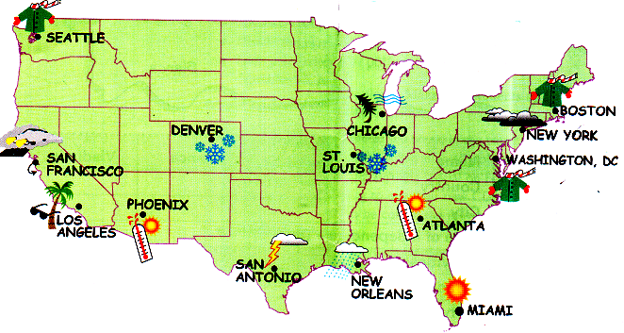
16. What’s the weather going to be like in Denver?
A. It’s going to rain
B. It’s going to snow
C. It’s going to be cold

17. What’s the weather going to de like in phoenix?
A. It’s going to be Sunny
B. It’s going to be windy
C. It’s going to rain

18. What the weather going to be like in Miami?
A. It’s going to be windy
B. there’s going to be storm
C. It’s going to be hot

19. What the weather going to be like in Washington?
A. It’s going to be hot
B. there’s going to be cold
C. It’s going to be warm

20. What the weather going to be like in Atlanta?
A. It’s going to be Sunny
B. It’s going to be windy
C. It’s going to rain

FRANCAIS 20%

Nom et prénom: _______________________________________

I. Écrivez les terminaisons:

a. Emilie est Canadien ____________. C´est une Journaliste
b. Elle S´appelle Justine. Elle est Français______________
c. Claudia est Italien______________. C´est une act _____________
d. María est Brésilien____________. C´est une étudiant___________
e. Elle S´appelle Pilar. Ell est Espagnol________________________

II. Orthographe: es, est, ou et?

1. Voilà Victoria Abril_______ Gerard Depardieu
2. Emilie Larue _________ Journaliste
3. Tu _________ étudiante?
4. Elle _______ actrices
5. Elle est étudiante _______ actrice

III. Complétez les phrases

1. J´habite ______________ Paris

a. à
b. a

2. Elle est _______

a. étudiant
b. étudiante

3. Il _________ pilote

a. est
b. es

4. Elle est ________

a. Italien
b. Italienne

5. Oui c´est __________ grande chambre

a. un
b. une

6. Elle ___________ 25 ans

a. a
b. à

Mettez le dialogue en ordre, puis écrivez le dialogue

Moi, Je m`appelle Benjamin. Bonjour, Aurélie

quelle est ta nationalité?

Bonjour, moi, Je m`appelle Aurélie. Et toi?

Je suis Français

