Fecha: ___________________________________

Nombre del estudiante: _______________________________________________________

- Color the pirate and help him get to the treasure that is down the dotted line.

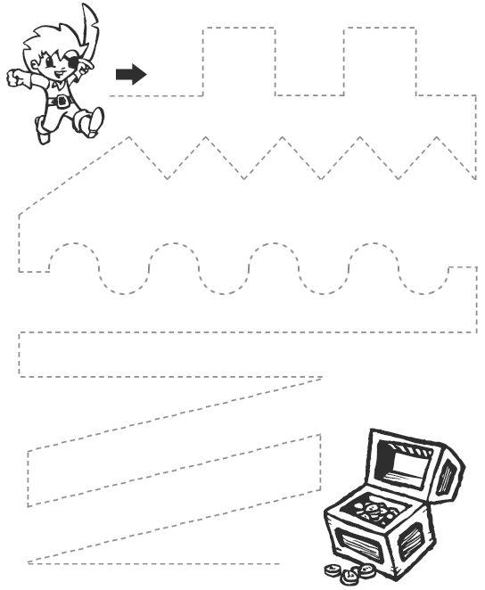

Fecha: ___________________________________ no: 02

Nombre del estudiante: _______________________________________________________

- Color the boy and the girl. Then, circle with yarn the boy that is down.
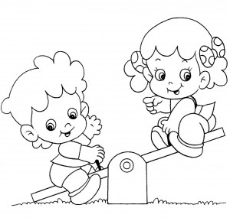

Fecha: ___________________________________ no: 03

Nombre del estudiante: _______________________________________________________

- Color the children and circle the boy that is up.
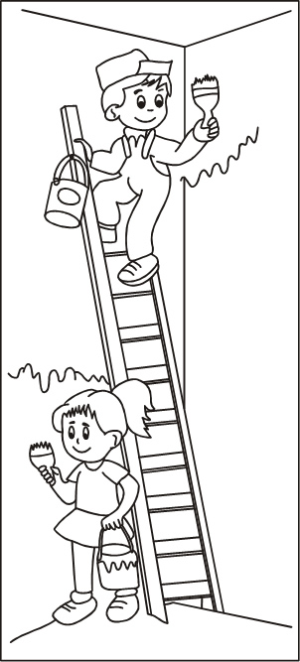

Fecha: ___________________________________ no: 04

Nombre del estudiante: _______________________________________________________

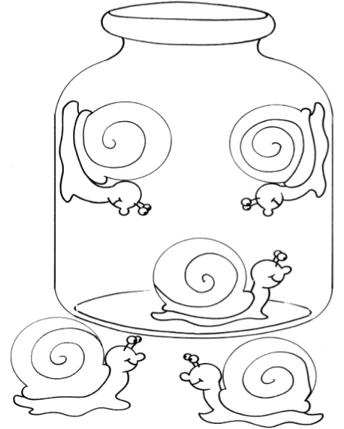
- Decorate the snales that are in the bottle.

Fecha: ___________________________________ no: 05

Nombre del estudiante: _______________________________________________________

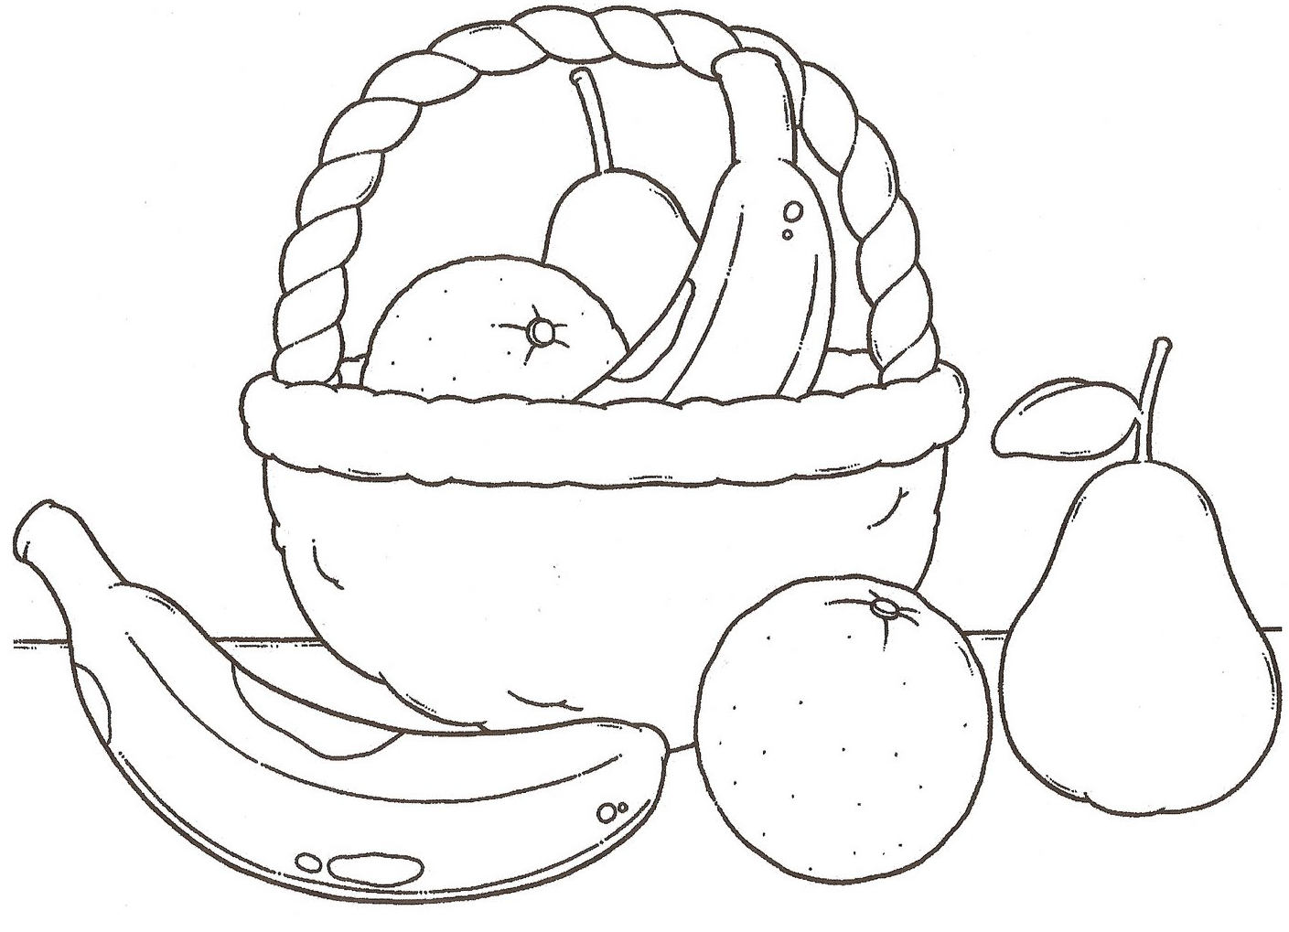
- Paint the fruits that are out of the basket.
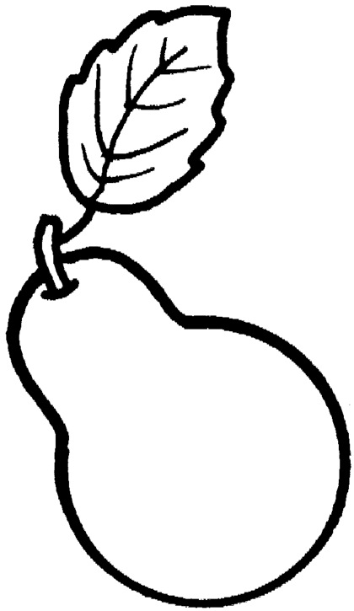
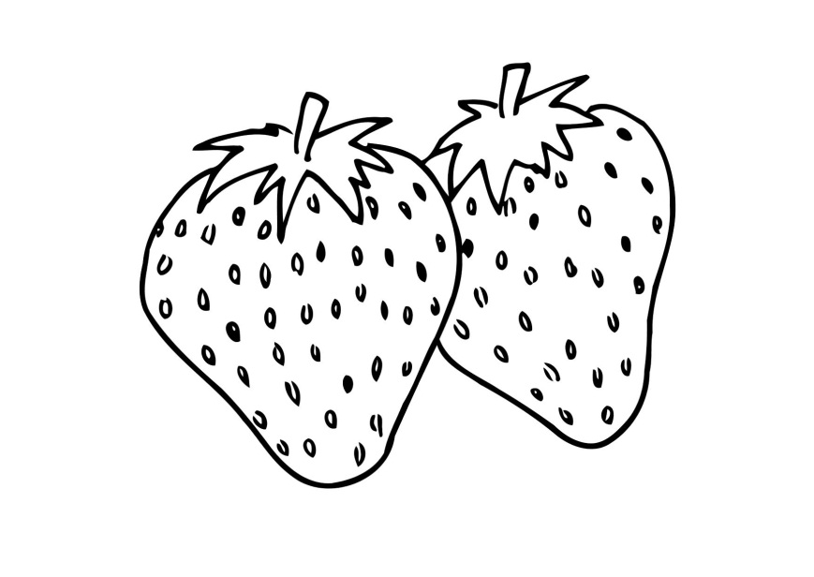

Fecha: ___________________________________ no: 06

Nombre del estudiante: _______________________________________________________

- Color the planes that go to the left.
