NOMBRE_______________________________________________ CURSO_____________
TEMA: school Suplies
PROPÓSITO: Learn school Suplies in english
MOTIVACIÓN: Listen the songs

GUÍA 004 READING
EVALUCACIÓN:
1. listen and learn the school supplies (Escuche y aprenda los Utiles escolares )
(2688) Kids vocabulary - School Supplies - Learn English for kids - English educational video - YouTube
2. Listen and learn “the school suplies song” (Escuche y aprenda los utiles escolares)
(2688) School Supplies Song | Fun Kids English - YouTube
3. listen and learn the classroom objects (Escucha y aprenda los objetos del salon de clase)
(2688) Classroom Objects for Kids (Objetos de Clase para niños) - YouTube

NOMBRE_______________________________________________ CURSO_____________
TEMA: School supplies
PROPÓSITO: Learn English through pictures, sounds and sentence examples!
MOTIVACIÓN: Listen the song (2688) School Supplies Song | Fun Kids English - YouTube

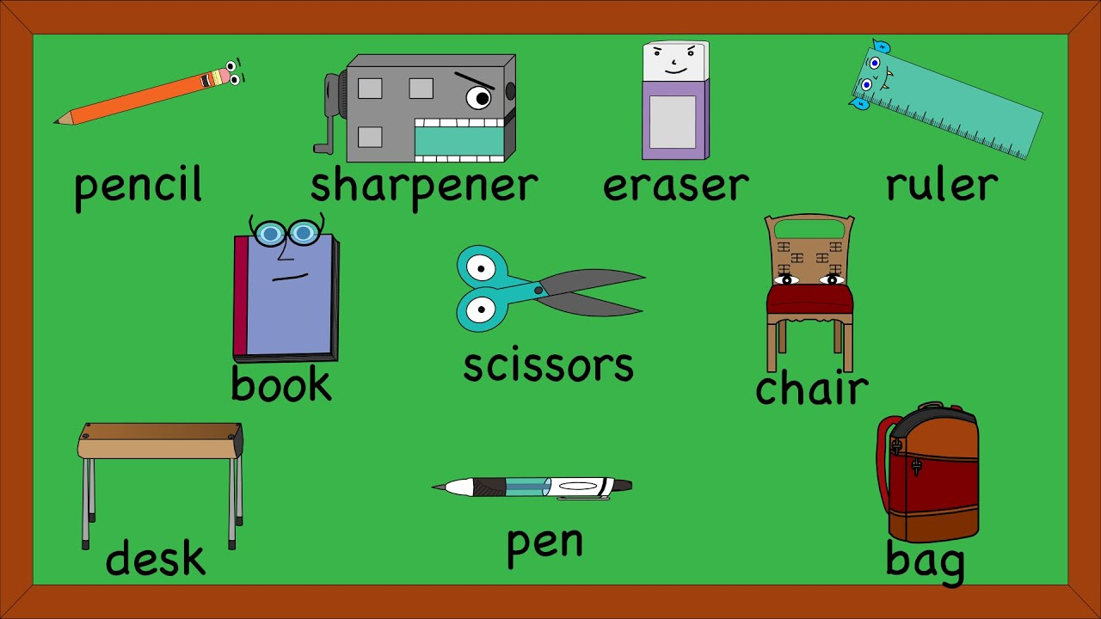
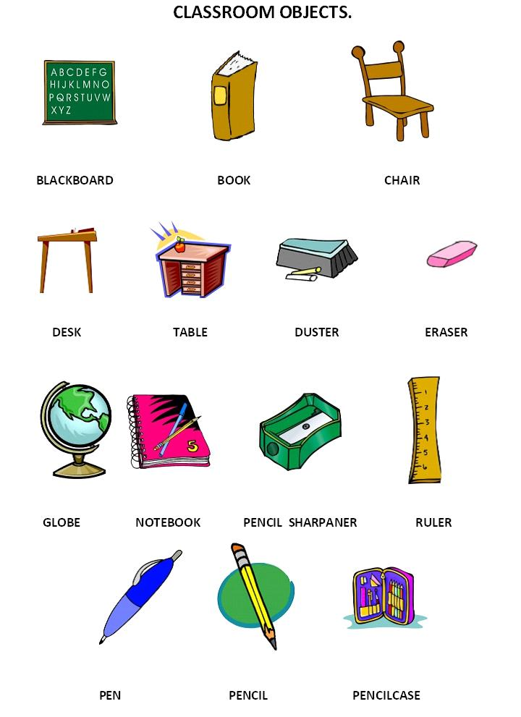
EXPLAIN:

EXERCISE
Find and color
A book a notebook a chair
A board a pencil a desk
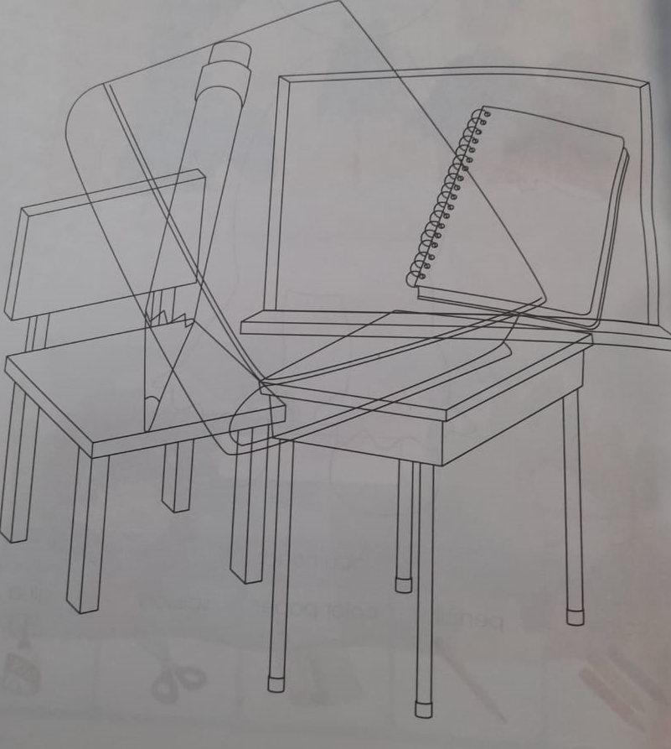

What is this

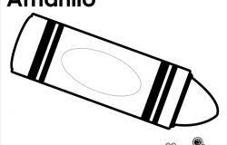


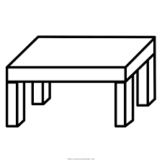
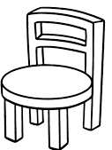

Chair
Table
Paper
Crayon
Book
Pencil

