 [Translated from Spanish to English - www.onlinedoctranslator.com](https://www.onlinedoctranslator.com/en/?utm_source=onlinedoctranslator&utm_medium=docx&utm_campaign=attribution)

 [Translated from English to Spanish - www.onlinedoctranslator.com](https://www.onlinedoctranslator.com/es/?utm_source=onlinedoctranslator&utm_medium=pdf&utm_campaign=attribution)

TRAINING

1. **Match sentences 1–5 with sentences a - e.**

|  |  |
| --- | --- |
| 1 What should I visit when I go to London? | a We don't want to get lost |
| 2 you shouldn't go alone | b You should visit the London Eye |
| 3 We should take a map with us | c In front of the monument. |
| 4 You should not forget to bring an umbrella. | d We must stick together. |
| 5 Where should we find you? | e It often rains in London. |

1. **Solve the exercises**

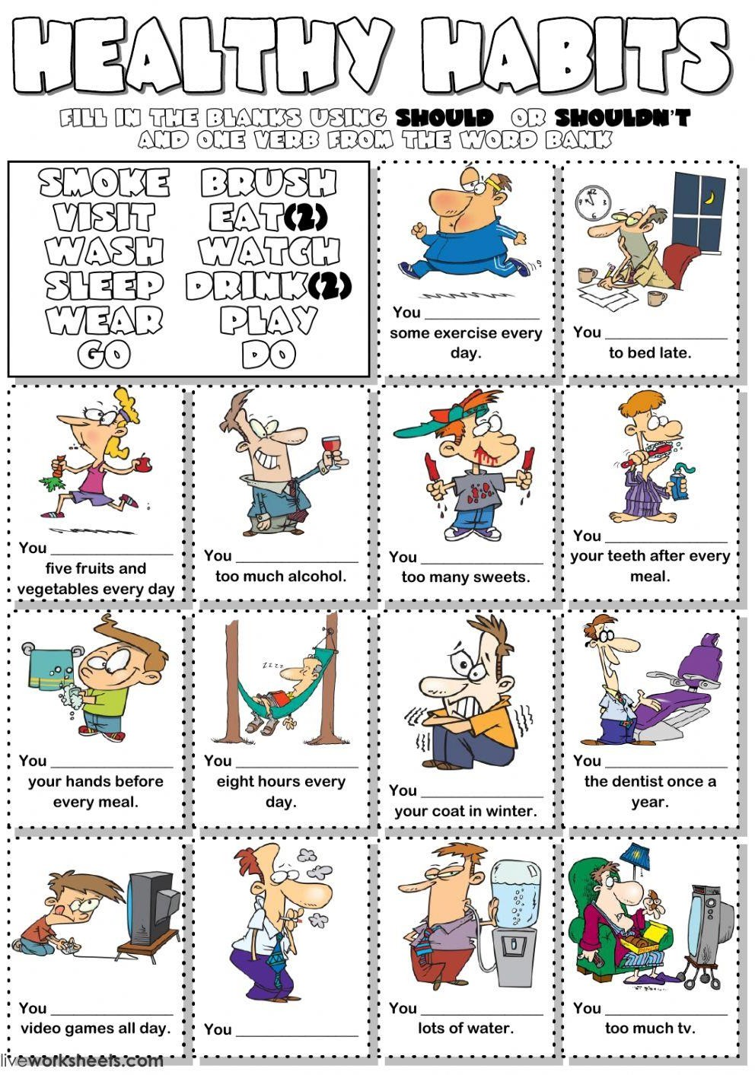

shouldnt

shouldnt

sholdnt

shouldnt

should

should

should

should

shouldnt

shouldnt

should

shouldnt

should

We should plant more three

We should have showers intead of baths

We shouldnt ligth compfires in the forest

We should use the public transports

We should replace old bulbs with led

We should recycle bottles and cans

We shoulndt cut down three

We shouldnt waste toilet

We should walk or cycle to school

We shouldnt turn the tap while washing our hands

We turn off the light when we leave a room

We should the garbage

We should use recycled bags

We should know toilet while washing the dishes

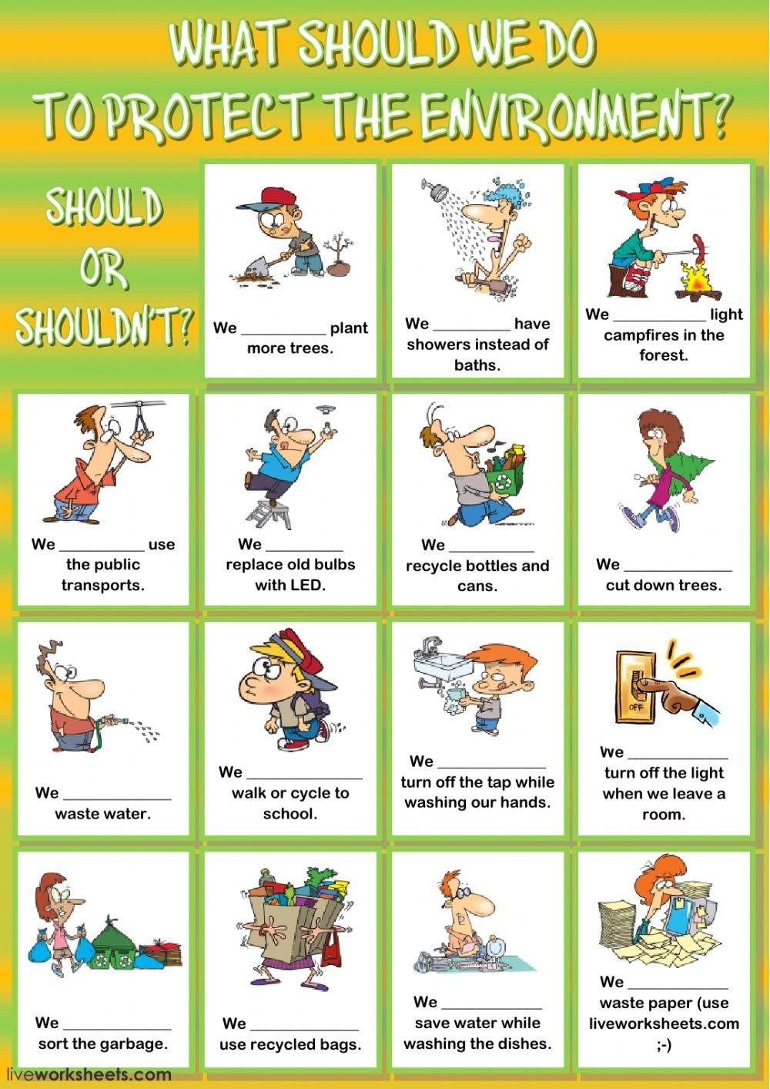

[Capture readers' attention with an important quote from the document, or use this space to highlight a key point. To place the text box anywhere on the page, just drag it.]



1. **Write should and shouldn't**
   1. you should / shouldn't be so selfish.
   2. I don't think you should / shouldn't smoke a lot.
   3. you should / shouldn't exercise more.
   4. I think you should / shouldn't try to talk to her.
   5. Have overweight. you should / should not go on a diet.
   6. Where should / shouldn't we park our car?
   7. You should / shouldn't talk to your mother like this.
   8. Children should / shouldn't spend so much time in front of the TV.
   9. **Should / Shouldn't**Am I telling the truth or should I not say anything?
   10. I think we should / shouldn't book our holidays in advance
2. **Choose the best option for each item. When you have smoke1.**YouI shouldn't drink (Do you drink much water.

a. should drink

1. I shouldn't drink
2. should drink
3. I shouldn't drink
4. You I shouldn't stay (you stay) in bed for a week.

must stay

1. I shouldn't stay
2. should be
3. I shouldn't stay
4. You should spend (you spend) time with other people.

a. should spend

1. I shouldn't spend
2. should spend
3. I shouldn't spend
4. You should take (takes) some pills and a cough syrup.

a. they must take

1. shouldn't take
2. should take
3. shouldn't take
4. You go out.

a. I should go

1. I shouldn't go
2. I should go
3. I shouldn't go
4. You I should go (eat) ice cream.

a. I should eat

1. I shouldn't eat
2. I should eat
3. I shouldn't eat
4. You they must take (takes) vitamin tablets.

a. should take

1. shouldn't take
2. they must take
3. shouldn't take
4. You are going to school.

a. I should go

1. I shouldn't go
2. I should go
3. I shouldn't go