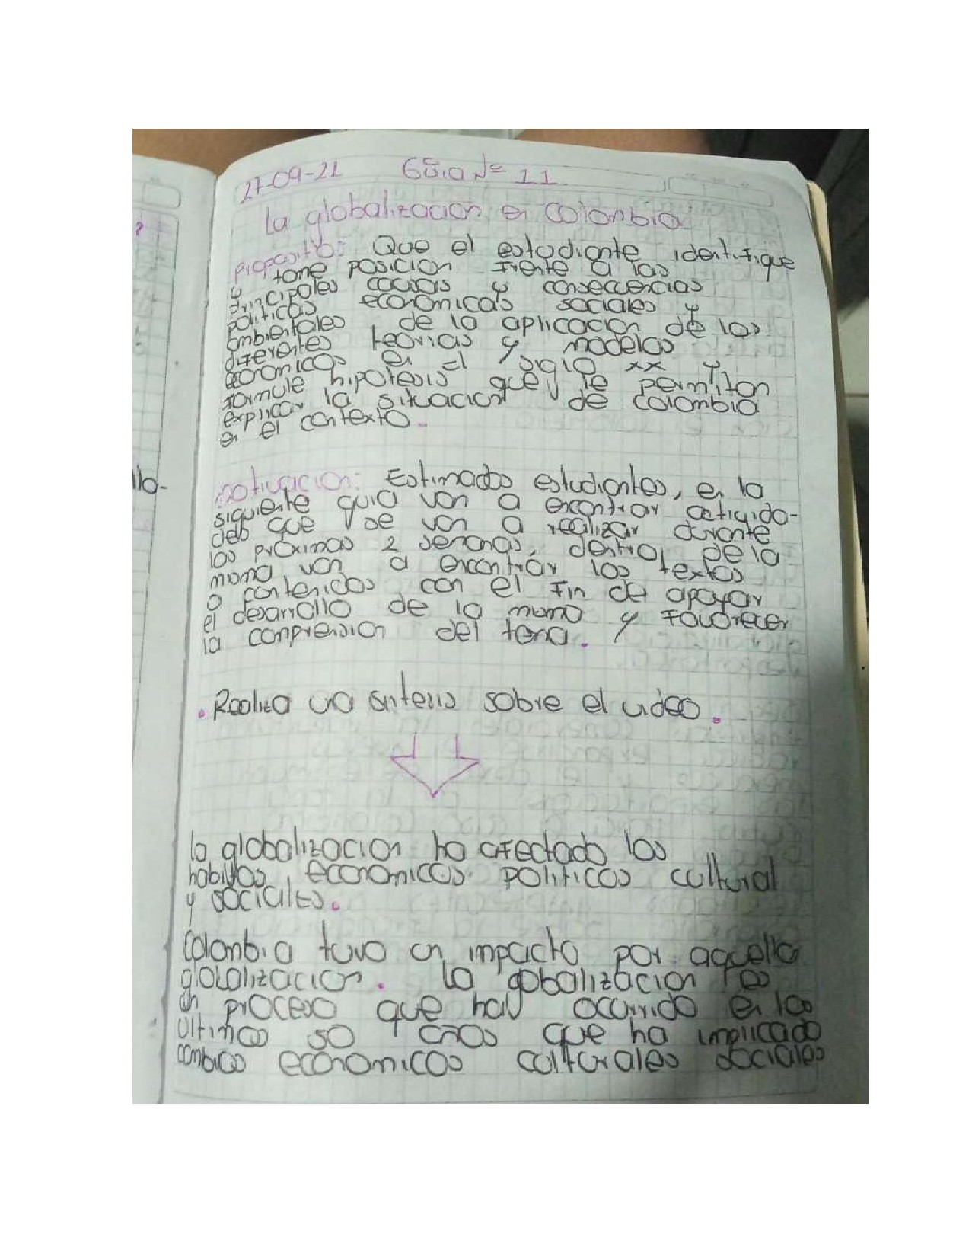

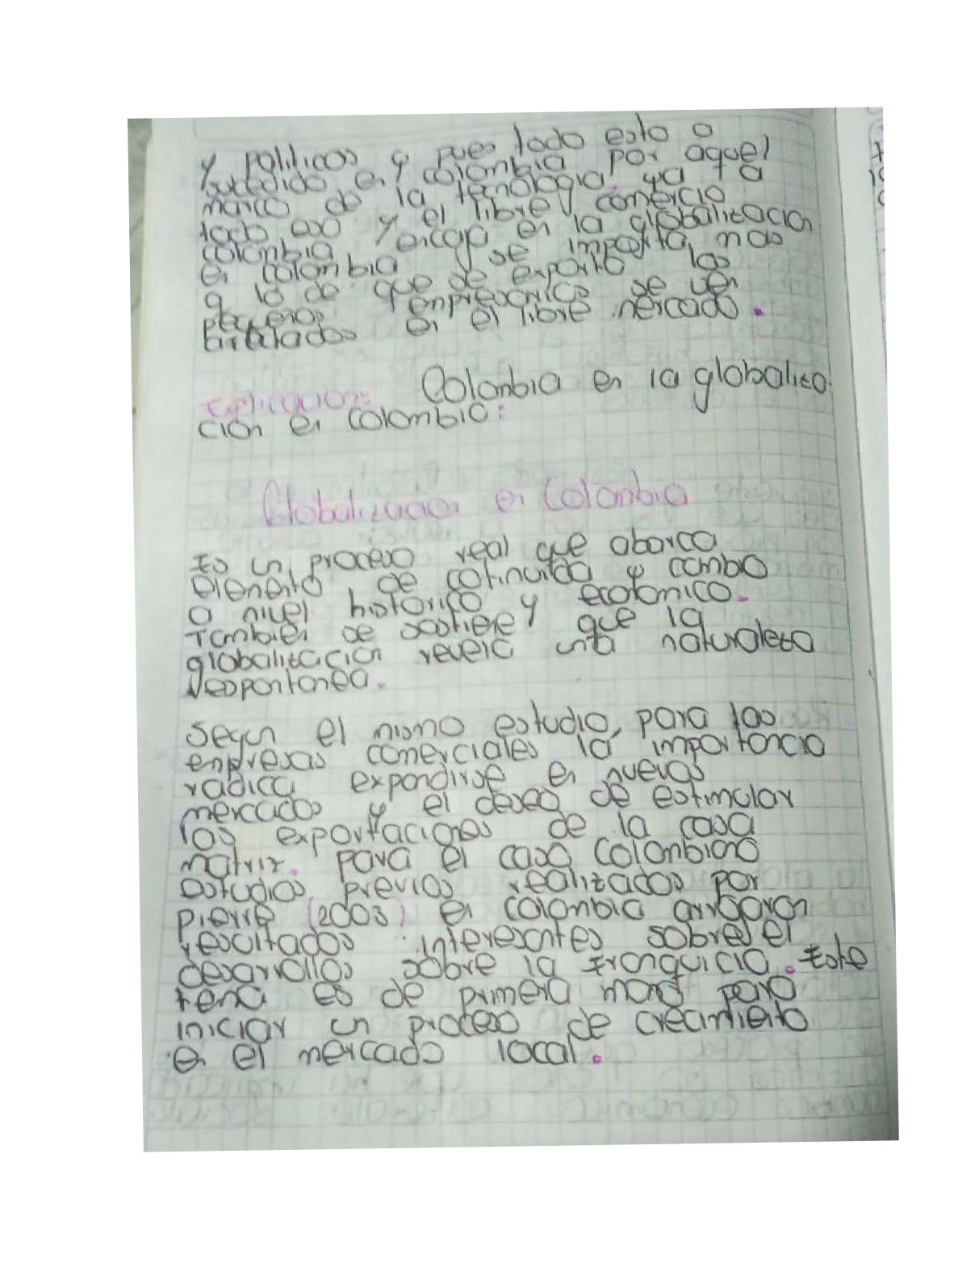

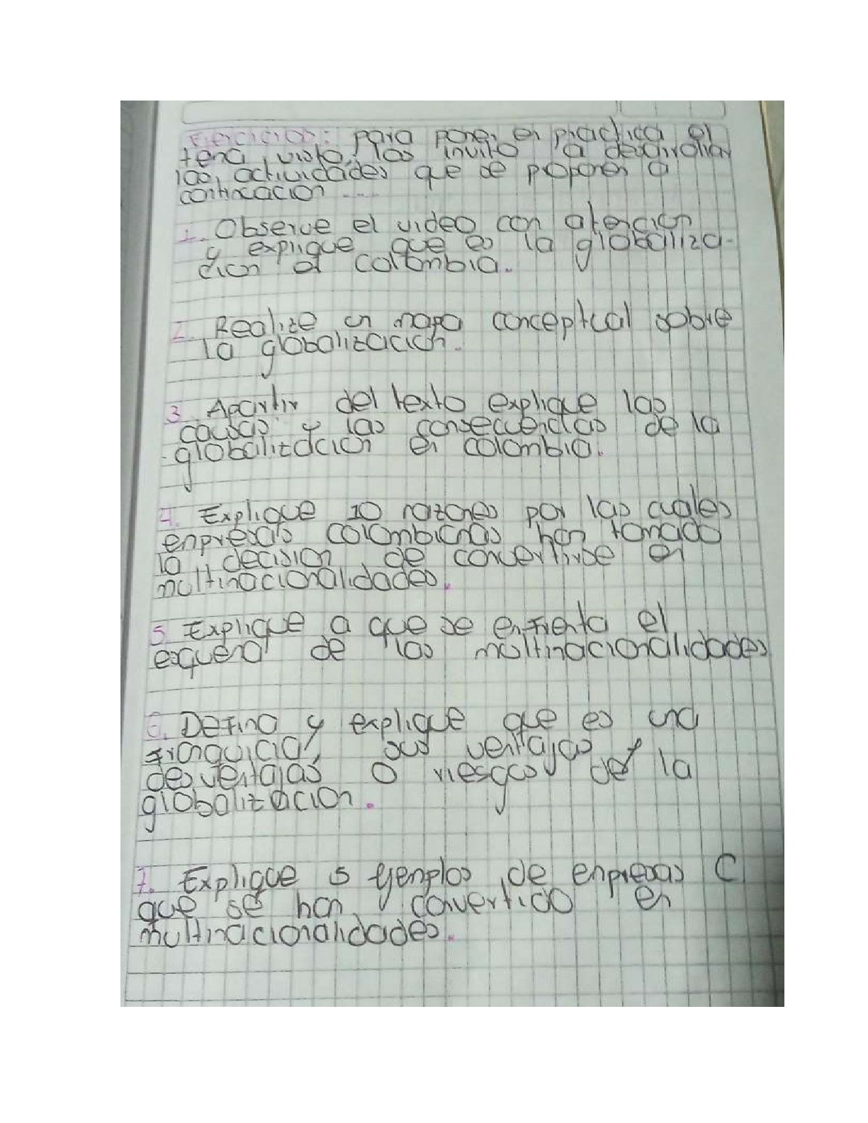

|  |  |
| --- | --- |
| 9〕  (℃  亻(J | \ 龢  ∕  4∕  冫 |
|

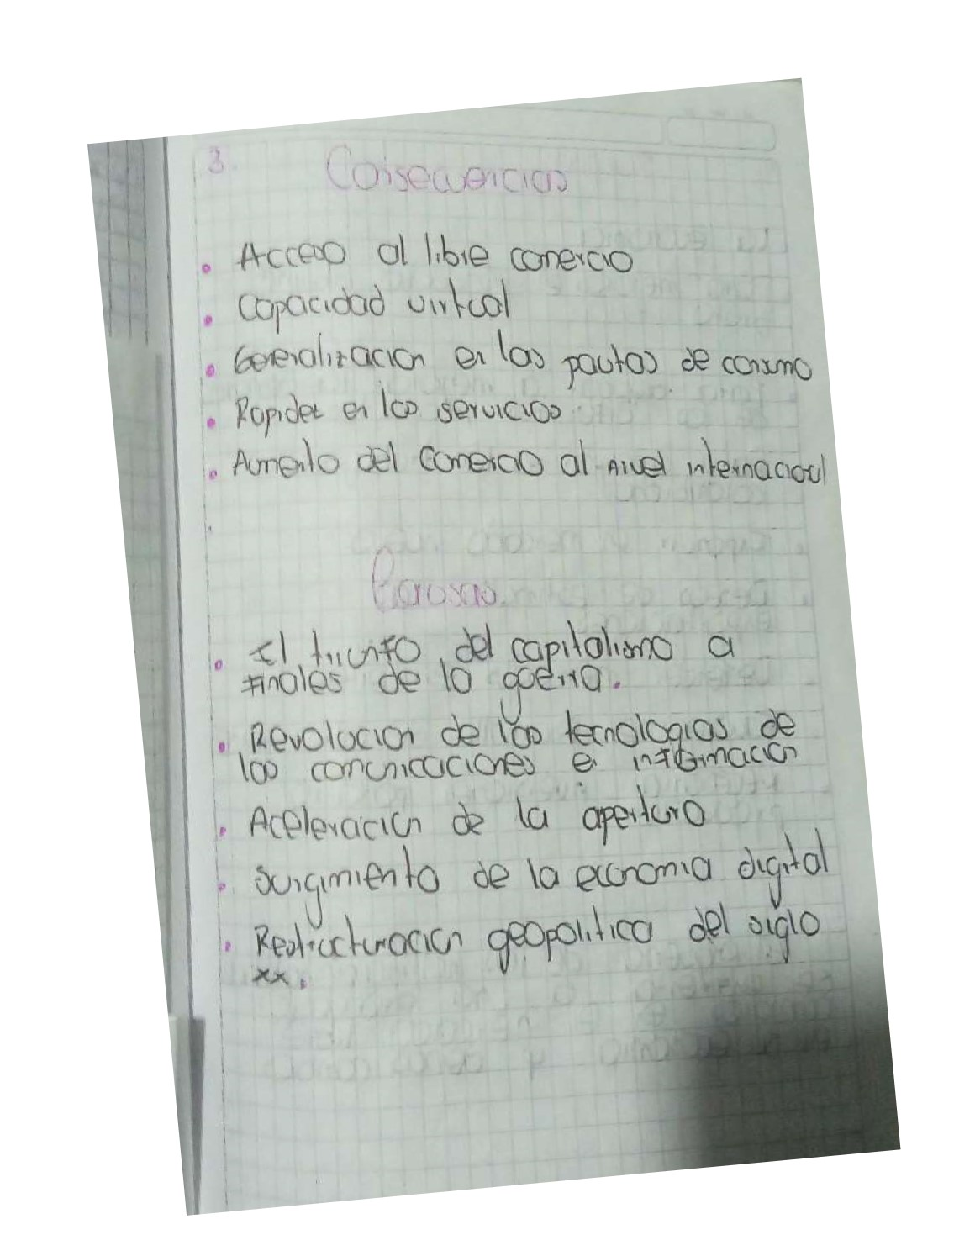

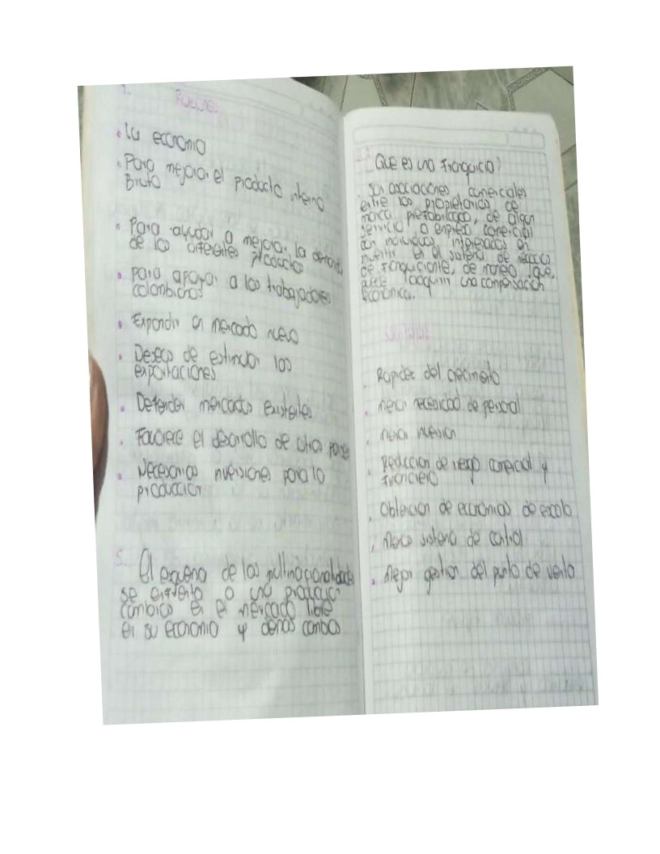

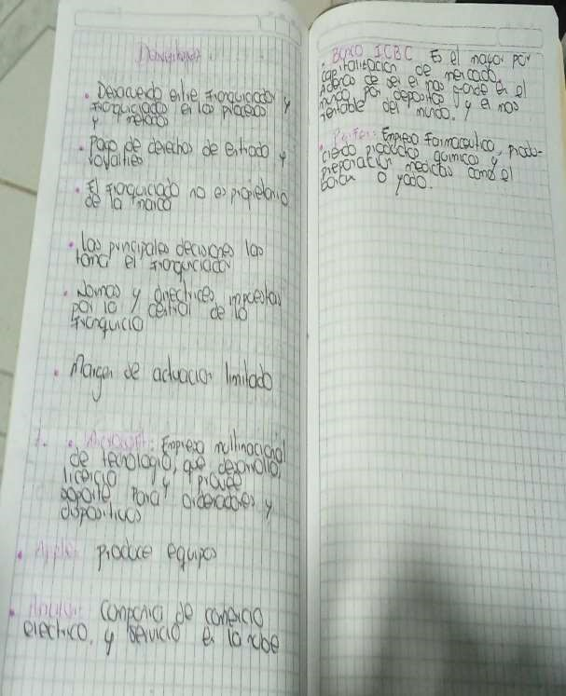

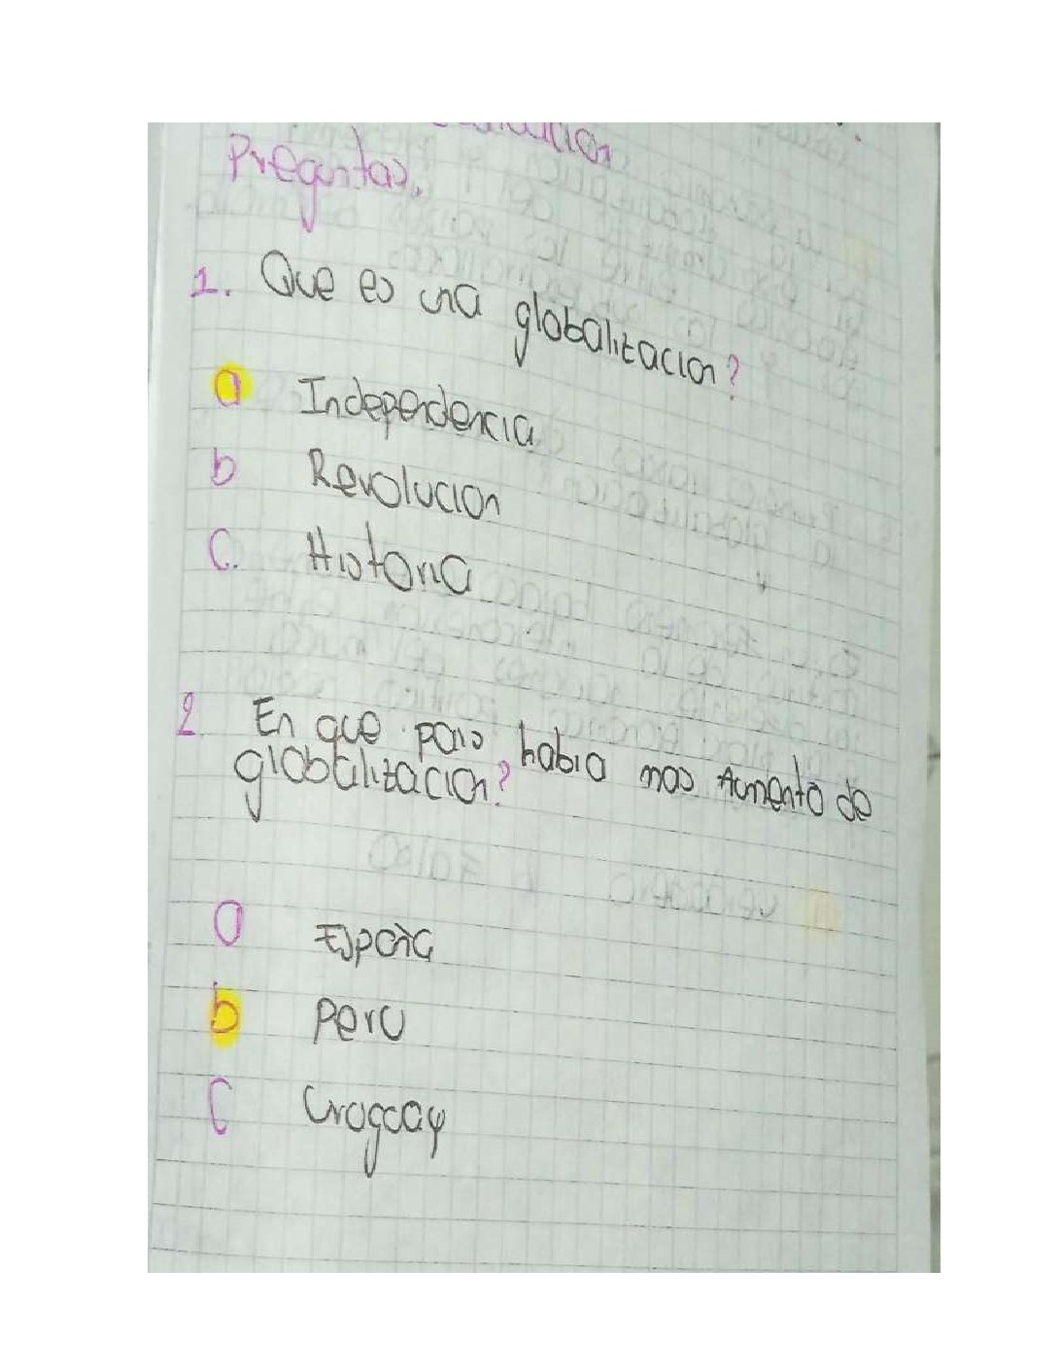

|  |  |  |
| --- | --- | --- |
| 0        Oro  b Q  」  …刂e | ℃ 孓  9rQ19 ~  b. | ~  1  ℃ |