# Talk about vacation

# Karen Sofia Ortiz Sierra

# Teacher: Liliana

# 11

# Miguel de Cervantes Saavedra

# 2021

# EXERCISES

* **Choose the correct word to complete the questions about holidays.**

1. When you are on holiday, do you like to *go / make* some sightseeing?
2. Do you often *buy / pay* souvenirs when you are on holiday? What kind?
3. Do you like *going / playing* skiing?
4. What do you always *make / pack* in your suitcase?
5. Do you like to explore new places or go *on / to* a guided tour?
6. Do you prefer to *live / stay* in a hotel or a youth hostel?
7. In the evening, do you go *dance / dancing* or chat to your friends?
8. When you eat *away / out*, what kind of restaurants do you like?
9. If you go to the beach, do you *get / have* sunburnt or do you use sun cream?

# 2. Read to four people, Bob, Andrea, Jim and Pauline describe something bad that happened on holiday.

1. **Bob**

It was stupid really. I was in the railway station and I was waiting for the train. This guy my age came up to me and asked me about a place to buy souvenirs. I couldn’t help him and then he went away. Then I noticed that my bag was open. Someone had stolen my digital camera. I had packed it in the front of my suitcase and someone had taken it while I was talking to the man. I think they were working as a team.

# Andrea

It was awful. I woke up in the middle of the night feeling ill. I had a fever and I started vomiting. It was the same for my parents. We had gone to a posh restaurant by the sea and we had eaten some prawns, and I’m sure that they had made me ill. I spent the whole next day in bed.

# Jim

I’m not a tourist. I’m a traveller but sometimes I get into trouble. Last year, I was in La Paz. Well, I hadn’t wanted to go on a guided tour so I just went to explore the city on my own using an app. The problem was that there was no WiFi and I couldn’t use my phone. I got completely lost. Luckily, I met this lovely old lady who took me back to my youth hostel. She was nice but it was a bit embarrassing really.

# Pauline

I was in Dubai and I was getting ready to go dancing with my friends when I looked in the mirror and my face was red. I was sunburnt! I had been on the beach all day and I hadn’t put on any sun cream because there were lots of clouds. I mean, in Britain, you don’t get sunburnt when it’s cloudy but the sun is very dangerous in Dubai. I was in agony!

# a. Please answer these questions Who …

1. made a mistake because of the weather?

Pauline was the one who made the mistake.

1. was a victim of crime?

Bob was the victim of a crime

1. got lost?

Jim was the one who got lost

1. became ill?

Andrea was the one who got sick

# b. Why do the people mention these things? Read again to check.

1. a camera

Bob mentions the camera because he realized it was stolen.

1. Prawns

Andrea mentions prawns because they ate them in the restaurant and she got sick.

1. a phone app

Jim mentions an application because with it he guided his way.

1. Clouds

Pauline mentions clouds because of the weather it was doing in Dubai

# c. Look at the events from the listening. Which one happened first? Which one happened second? Write 1 or 2.

1. **__2__**Then I noticed that my bag was open. 1 Someone had stolen my digital camera.
2. **2** I woke up in the middle of the night feeling ill. 1 We had eaten some prawns.
3. **1** I hadn’t wanted to go on a guided tour. 2 I just went to explore the city on my own.
4. **1** My face was red. 2 I had been on the beach all day and I hadn’t put on any sun cream.

# Look at the pictures. Do you know what they show? Where is this place? Why is this place important? Read the text quickly to check your answers.

**In the Palm of Dubai**

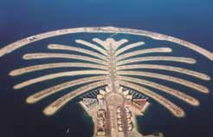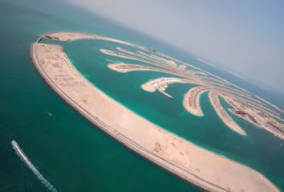

1. **E** It’s incredible, burning, often over 40 degrees Celsius in the summer months. Part of the United Arab Emirates (UAE), Dubai is a city in the middle of the desert. Where the pavement ends, sand begins and it stretches for kilometres and kilometres into the distance. Despite this harsh climate, the people of Dubai have turned their city into one of the world’s most popular tourist resorts.
2. A There are five star hotels that you need special permission to visit. If you want to buy souvenirs, you can buy gold jewellery from a vending machine. The shopping malls are enormous palaces with every luxury product you could think of.
3. **F** One of the most famous is the Palm Island. This is an artificial island built in the sea right next to the city. It is the site of luxury homes and hotels, although it’s not actually the best place to go sightseeing. It’s only possible to see the palm shape from the air.
4. **C** To build the Palm Island, the developers destroyed both a place where turtles lay their eggs as well as the only coral reef along the coast. The coral was an essential habitat for marine life and although there are plans to replace it with an artificial reef, the damage has already been done.
5. **G** Large numbers of people are moving to live in Dubai and they all need water, something which is not easily available in the desert. The solution is to use desalination plants, factories which turn sea water into fresh water. These use enormous amounts of electricity and produce large amounts of CO2.
6. **D** On the one hand, we want to make pleasant places for people to live and exciting locations for tourists to enjoy. This creates jobs for people where there is no other work. On the other hand, development often equals destruction and the environment suffers as a result.

# Complete the opening sentence of each paragraph 1-6 with a-g. There is one extra sentence.

1. In Dubai, wealth is everywhere.
2. The question is whether this development has had too great a negative impact.
3. In conclusion, Dubai represents many of the problems that we have in the modern world.
4. The original inhabitants lived a peaceful life, making their homes in tents in the desert.
5. The first thing you notice when you arrive in Dubai is the extreme heat.
6. To attract visitors, Dubai has begun many huge construction projects.
7. That is not the only environmental problem.

# Look again at the text. Make notes under these headings.

|  |  |
| --- | --- |
| **The needs of tourists and people** | **How development affects the environment** |
| T  The needs of tourists and people are water and an appropriate habitat for them and the environment | the environment is affected by the constructions that are made there and they often destroy the entire habitat. |

1. **Now answer these questions.**
   1. **1.** What kind of people go to Dubai as tourists?

the kind of people who go to Dubai are the ones who have a lot of money.

1. What is the natural environment like in Dubai?

the natural environment is very bad.

1. Is there any wildlife in Dubai?

if there is wildlife

1. Why do people allow development in Dubai when it has a negative effect on the environment?

people allow it for wealth and power.

1. Do you think people are making the right or the wrong decisions in Dubai?

I think they are making the wrong decisions.

1. Do you think there are similar problems in your country?

I think so.

1. What do you think is more important: jobs from tourism or protection of the environment?

I think the most important thing is the protection of the environment.

# write a topic sentence for each of these paragraphs.

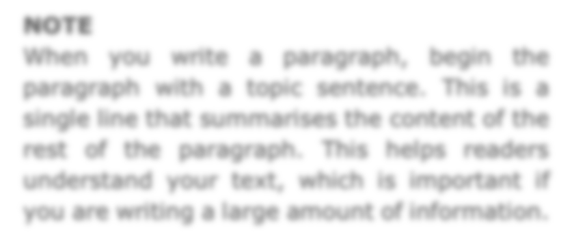

**NOTE**

When you write a paragraph, begin the paragraph with a topic sentence. This is a single line that summarises the content of the rest of the paragraph. This helps readers understand your text, which is important if you are writing a large amount of information.



**1.** One example is a miniature Statue of Liberty. Other visitors like to buy fridge magnets of famous places in the city such as Times Square or the Brooklyn Bridge. Most famous of all, of course, is a T-shirt that says ‘I ª NY’.



**2.** Recently there was a famous photograph of one walking on a beach where turtles lay their eggs. It is obvious that this a bad idea so why do people behave like this when they go on holiday?



**3.** One way is to keep out of the sun between 10 am and 2 pm every day when it is most dangerous. If this is impossible, apply plenty of suncream and wear a hat to ensure you have enough protection.



4. Perhaps the best option is Dino’s, a classic Italian pizzeria in the city centre. The Nagano Sushi Bar is extremely popular for Japanese food, but you need to book in advance because it’s very small and always fully booked at weekends.



**5.** Actually many young people don’t like staying in that sort of accommodation. It’s too posh and the other customers are much older than them. Teenagers prefer youth hostels for their fun environment and also because it’s an excellent place to meet people when you are travelling.

1. it is something magical that people take from this place
2. It is a photo that you feel is disrespectful to an animal
3. Advice for when you go to the sea
4. We give you two great options, a delicious Italian pizza or a delicious Japanese meal.
5. An elegant place, but a little different from what teenagers are looking for.
6. One piece of advice, when you go to travel try not to take your whole house.



**6.** As a result, you have to pay more money if your suitcase weighs more than 20 kilos. This means you need to pack carefully. Only take small bottles of liquids like shampoo. Leave heavy books at home and take an e-reader which weighs much less. If you have a coat, wear it and don’t put it in your bag, especially if it’s a thick winter coat for a skiing trip