8. FUTURE PERFECT

Juan David Clavijo Lastra

Grado: 11

Liliana Martínez Granada

Miguel De Cervantes Saavedra

Ingles

Ibagué

2021

**EXERCISES**

**1. Read and fill in the blanks with words from the box.**

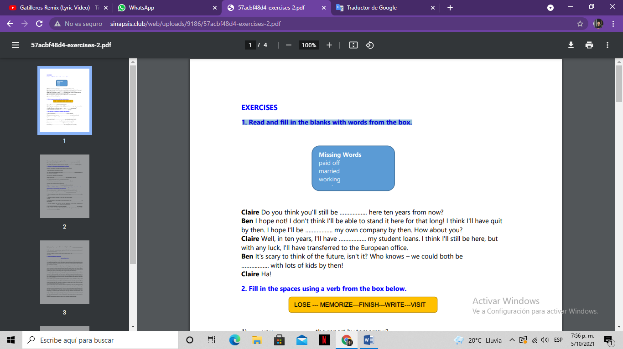

Claire Do you think you'll still be ……working.. here ten years from now? Ben I hope not! I don't think I'll be able to stand it here for that long! I think I'll have quit by then. I hope I'll be …working.. my own company by then. How about you? Claire Well, in ten years, I'll have …paid off…….. my student loans. I think I'll still be here, but with any luck, I'll have transferred to the European office.

Ben It's scary to think of the future, isn't it? Who knows – we could both be ……maried….. with lots of kids by then! Claire Ha!

**2. Fill in the spaces using a verb from the box below.**

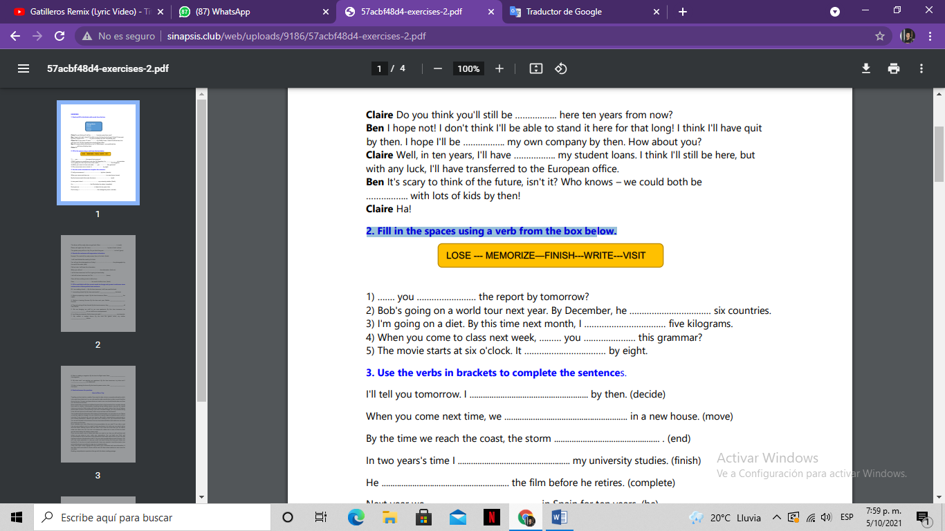

1) …Have…. you ………write…………… the report by tomorrow?

2) Bob's going on a world tour next year. By December, he ………Visits………… six countries.

3) I'm going on a diet. By this time next month, I ……lose…………… five kilograms.

4) When you come to class next week, …I´ii have…… you ……memorize…… this grammar?

5) The movie starts at six o'clock. It ………Finishes…………… by eight.

**3. Use the verbs in brackets to complete the sentences.**

I'll tell you tomorrow. I .......I´ii decide................................... by then. (decide)

When you come next time, we ..............will move............................. in a new house. (move)

By the time we reach the coast, the storm ........will end .............................. . (end)

In two years's time I .........will finish.............................. my university studies. (finish)

He ...........will complete....................................... the film before he retires. (complete)

Next year we ...........will be.......................... in Spain for ten years. (be)

Don't worry. I .............will contact........................... the manager by noon. (contact)

The dinner will be ready when we get back. Mum ..............will cook........................... it. (cook)

Please, call again later. Mr. Jones ...........returns................................. by two o'clock. (return)

The garden party will be in July. Do you think the grass ..........will grow................... in time? (grow)

**4. Rewrite the sentences with expressions in brackets.**

Example The meal will be ready sooner than at 6 o'clock. (finish)

I will have finished the meal by 6 o'clock.

You will get the photographs on Friday. I ......... I will be taking........................ the photographs by

the end of the week. (take)

Call me later. I will know the information.

When you call me I ........ I will tell you what I found out............... the information. (find out)

I will be here tomorrow, but Tim is going to leave today.

I will still be here tomorrow, but Tim ......... Will be leaving................................... (leave)

Clare will have nothing to do in half an hour.

Clare ............ Will have finished.............................................. her work in half an hour. (finish)

**5. Fill in each blank with the correct words to change each present continuous tense sentence into a future perfect tense sentence:**

**EX:** I am reading a book --> By this time tomorrow, I will have read the book.

1. I am writing a book. By this time next month, I ________will have posted_________ the book. 2. Maria is preparing a report. By this time tomorrow, Maria ________will be over_____________ the report.

3. Martha is learning German. By this time next year, Martha _________will have learned_______ German.

4. They are inviting all their friends. By this time tomorrow, they ______will have arrived________ all their friends.

5. We are bringing our stuff to our new apartment. By this time tomorrow, we

_____will have carried_______________ all our stuff to our new apartment.

6. I am fixing my computer. By this time next week, I ________will have arranged_________ my computer.

7. My mother is making dinner. By the time the guests arrive, my mother _______will have served________ dinner.

8. Peter is reading a magazine. By the time his flight lands, Peter _________will have read_______ the magazine.

9. My sister and I are painting our apartment. By this time tomorrow, my sister and I __________will have painted__________ our apartment.

10. John is cleaning the house. By the time his parents arrive, John ___________will have cleaned____________ the house.

**6. Read and answer the questions**

**How to Plan a Trip**

Traveling can be tricky for a newbie. If you want to take a trip to a new place abroad or which is far away from where you live, you may need to make a good plan in order to avoid troubles during the trip. So once you know where you want to go, you should decide when and how you are going to go there. Many people take a trip during holidays because that is the time when they can take a break from work or studies. Unfortunately, traveling during holiday season may not be a good choice as prices for flight tickets and hotel rooms are usually higher than the off-season period when tourism is not booming. If you have a limited budget, you may consider taking a day off work during the off-season when prices are lower and discounted. Your budget will also determine what means of transportation you are going to use. Taking a road trip might be cheaper, but you should be in good shape and prepare your car for a long trip. If you choose to fly, you may have to take public transportation to get around in your holiday destination. Whether you take a taxi, subway or bus, you should know where you are going based on the itinerary that you have planned before and make sure you know the routes and the fares.

Next, calculate your costs. What kind of accommodation do you want? If you take a road trip, you may prefer to stay in a motel. Hostels are cheaper, but today you can search online and find hotels offering rooms with low rates. If the costs are more than you can afford, make cuts where you can. You may cut expenses for eating out or even cut the trip short and get back before the holiday season ends. Once you are exactly sure of where and when you want to go, how you will get there and where you are going to stay, make your reservations. You can book your flight and accommodation online and even many attractions have ticket sales online so you can skip the lines and enjoy the attraction right in. You may also consider taking travel insurance. You will have some protection in case you could not travel during the time your tickets are booked for. If you plan to travel internationally, keep your passport, travel documents, visas and similar items in one place to ease you in accessing them. Lastly, pack light. Heavy luggage will only restrict your movement and cause discomfort. A few basic shirts and pants or shorts will do and roll them when packing to save room for souvenirs.

Reading comprehension questions that go with the above reading passage.

**1) When is the best time to take a cheap trip?**

A) During the holiday season.

B) During the off-season.

C) During the peak period.

D) During the day off.

**2) What is the advantage of taking a road trip compared to flying?**

A) A road trip is longer.

B) A road trip could be dangerous.

C) A road trip is usually cheaper.

D) A road trip requires you to be in good shape.

**3) If your budget for accommodation is very limited, you can do the following,**

**EXCEPT:**

A) Stay in a luxury hotel.

B) Stay in a hostel.

C) Cut your trip short.

D) Find a low rate hotel room.

**4) What is travel insurance for?**

A) To protect your health during the trip.

B) To give protection if you lose your luggage.

C) To give protection when traveling

D) To give protection if you should cancel your booking.

**5) Why should you bring light luggage?**

A) To restrict your movement.

B) To save your energy.

C) To ease you in moving around.

D) To give space for camping equipment.