KAROL DAYANNA RACINES C

GRADO 11

2. Read to four people, Bob, Andrea, Jim and Pauline describe something bad that happened on holiday.

Bob

It was stupid really. I was in the railway station and I was waiting for the train. This guy my age came up to me and asked me about a place to buy souvenirs. I couldn’t help him and then he went away. Then I noticed that my bag was open. Someone had stolen my digital camera. I had packed it in the front of my suitcase and someone had taken it while I was talking to the man. I think they were working as a team.

Andrea

It was awful. I woke up in the middle of the night feeling ill. I had a fever and I started vomiting. It was the same for my parents. We had gone to a posh restaurant by the sea and we had eaten some prawns, and I’m sure that they had made me ill. I spent the whole next day in bed.

Jim

I’m not a tourist. I’m a traveller but sometimes I get into trouble. Last year, I was in La Paz. Well I hadn’t wanted to go on a guided tour so I just went to explore the city on my own using an app. The problem was that there was no WiFi and I couldn’t use my phone. I got completely lost. Luckily, I met this lovely old lady who took me back to my youth hostel. She was nice but it was a bit embarrassing really.

Pauline

I was in Dubai and I was getting ready to go dancing with my friends when I looked in the mirror and my face was red. I was sunburnt! I had been on the beach all day and I hadn’t put on any suncream because there were lots of clouds. I mean, in Britain, you don’t get sunburnt when it’s cloudy but the sun is very dangerous in Dubai. I was in agony!

➢ Please answer these questions Who …

1. made a mistake because of the weather?

Pauline

1. was a victim of crime?

Bob

1. got lost?

Jim

1. became ill?

Andrea

➢ Why do the people mention these things? Read again to check.

a. camera

b. prawns

c. a phone app

d. clouds

R/= to make it relevant

➢ Look at the events from the listening. Which one happened first? Which one happened second? Write 1 or 2.

a. __1__Then I noticed that my bag was open. ___2__ Someone had stolen my digital camera. b. _____1___I woke up in the middle of the night feeling ill. __2__We had eaten some prawns.

c. __1____I hadn’t wanted to go on a guided tour. ____2__I just went to explore the city on my own.

d. ____1___My face was red. ____2___I had been on the beach all day and I hadn’t put on any suncream.

3. at the pictures. Do you know what they show? Where is this place? Why is this place important? Read the text quickly to check your answers

1. E incredible, burning, often over 40 degrees Celsius in the summer months. Part of the United Arab Emirates (UAE), Dubai is a city in the middle of the desert. Where the pavement ends, sand begins and it stretches for kilometres and kilometres into the distance. Despite this harsh climate, the people of Dubai have turned their city into one of the world’s most popular tourist resorts.
2. A There are five star hotels that you need special permission to visit. If you want to buy souvenirs, you can buy gold jewellery from a vending machine. The shopping malls are enormous palaces with every luxury product you could think of.
3. F One of the most famous is the Palm Island. This is an artificial island built in the sea right next to the city. It is the site of luxury homes and hotels, although it’s not actually the best place to go sightseeing. It’s only possible to see the palm shape from the air.
4. B To build the Palm Island, the developers destroyed both a place where turtles lay their eggs as well as the only coral reef along the coast. The coral was an essential habitat for marine life and although there are plans to replace it with an artificial reef, the damage has already been done.
5. C numbers of people are moving to live in Dubai and they all need water, something which is not easily available in the desert. The solution is to use desalination plants, factories which turn sea water into fresh water. These use enormous amounts of electricity and produce large amounts of CO2.
6. G On the one hand, we want to make pleasant places for people to live and exciting locations for tourists to enjoy. This creates jobs for people where there is no other work. On the other hand, development often equals destruction and the environment suffers as a result.

➢ Complete the opening sentence of each paragraph 1-6 with a-g

There is one extra sentence

a. In Dubai, wealth is everywhere.

b. The question is whether this development has had too great a negative impact.

c. In conclusion, Dubai represents many of the problems that we have in the modern world.

d. The original inhabitants lived a peaceful life, making their homes in tents in the desert. e. The first thing you notice when you arrive in Dubai is the extreme heat.

f. To attract visitors, Dubai has begun many huge construction projects.

g. That is not the only environmental problem.

4. again at the text. Make notes under these headings.

|  |  |
| --- | --- |
| **The needs of tourists and people**  The needs of tourists and sorry is to be able to visit and know new places and live new experiences. | **How development affects the environment**  Developmenth affects In every way because they are destroying the vegetation and every day there is more pollution. |

5. Now answer these questions.

1. What kind of people go to Dubai as tourists?

R/= Tourists.

2. What is the natural environment like in Dubai?

R/= Bad, destroyed both a place where turtles lay their eggs as well as the only coral reef along the coast.

3. Is there any wildlife in Dubai?

R/= No

4. Why do people allow development in Dubai when it has a negative effect on the environment? so that tourism continues to increase

5. you think people are making the right or the wrong decisions in Dubai?

R/= Wrong.

6.you think there are similar problems in your country?

R/= yes

1. do you think is more important: jobs from tourism or protection of the environment?

R/= The environmental protection.

➢ Write a topic sentence for each of these paragraphs.

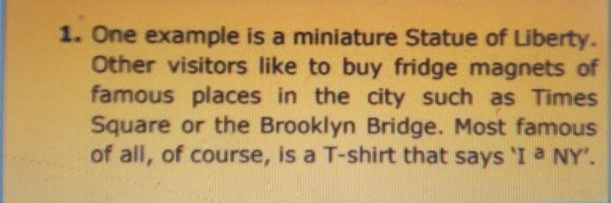

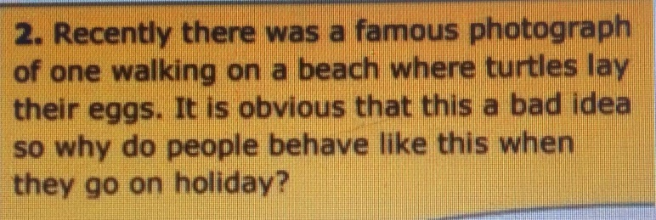

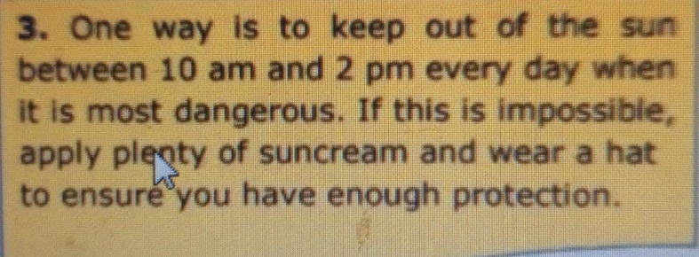

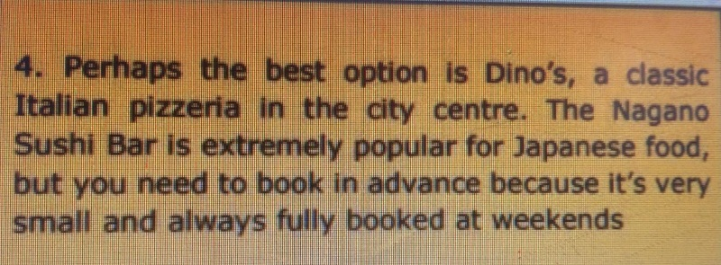

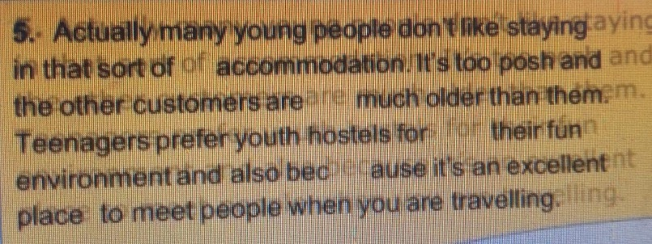

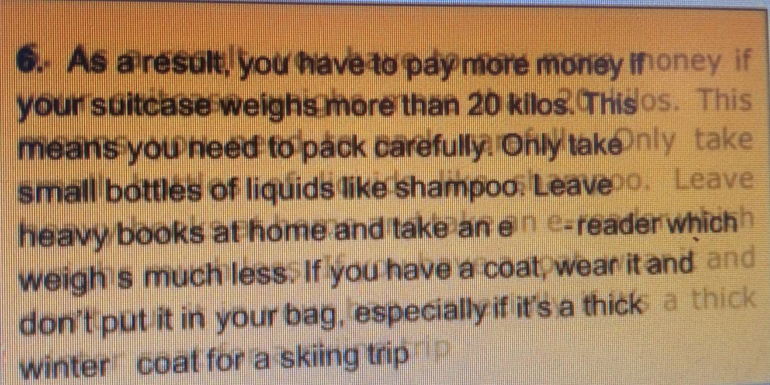

A famous photograph was recently published of a person walking on a beach where turtles lay their eggs. This is obviously a bad idea, so why do people behave like this when they go on vacation? BECAUSE THEY THINK THAT THAT IS FUN AND THINK THAT TURTLES DO NOT FEEL PAIN

it is about taking care of ourselves both physically and mentally, it is also knowing how to behave when we are on holidays and be more conscious of what we are doing