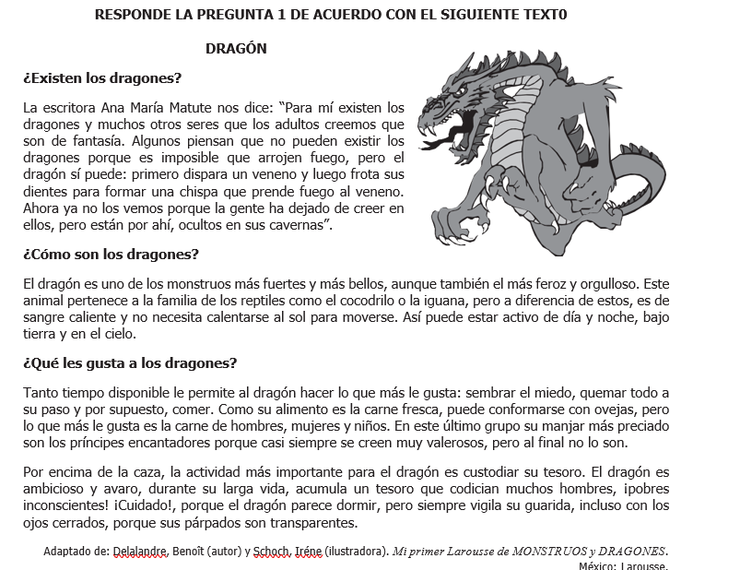

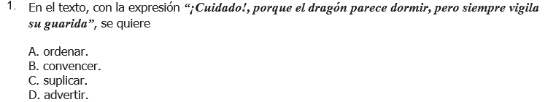

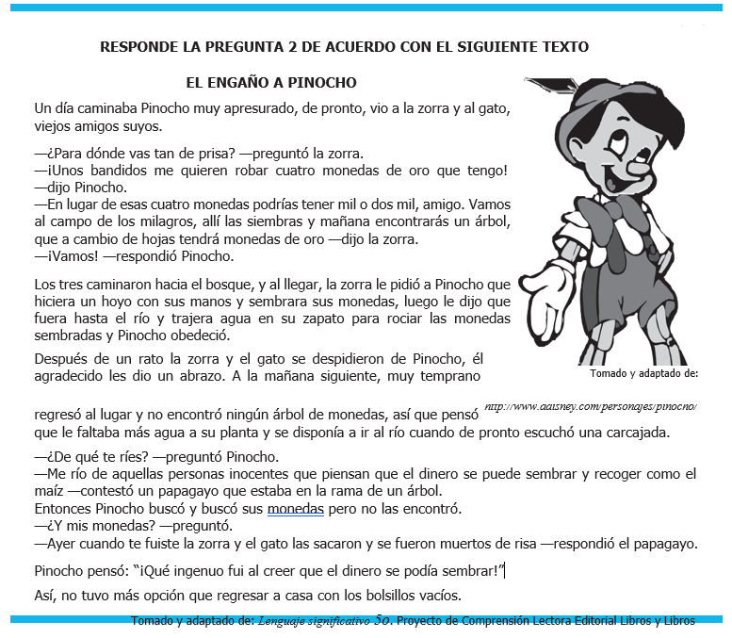



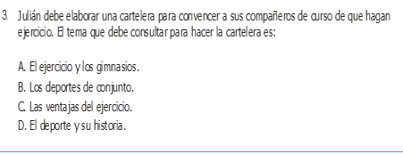

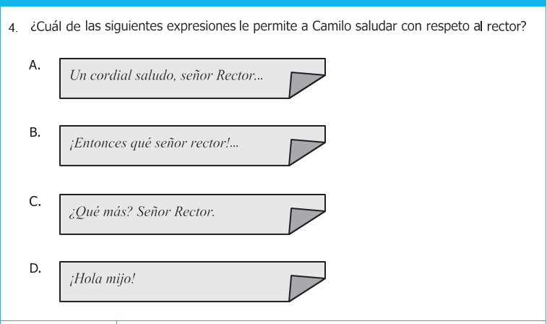

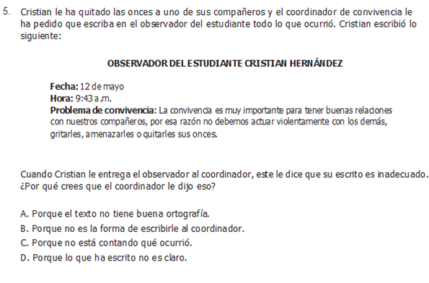

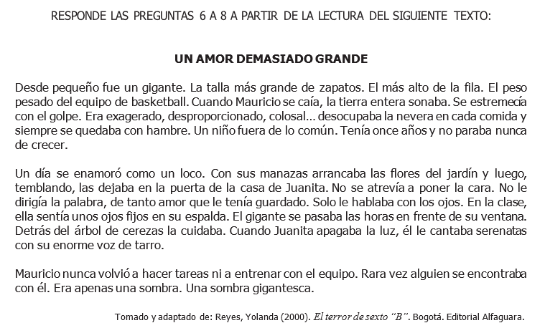

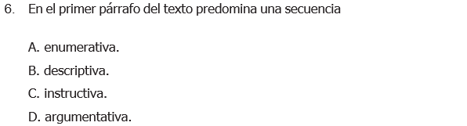

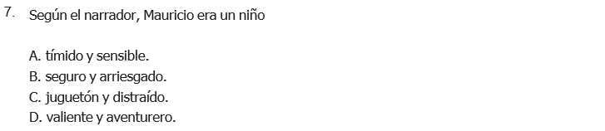

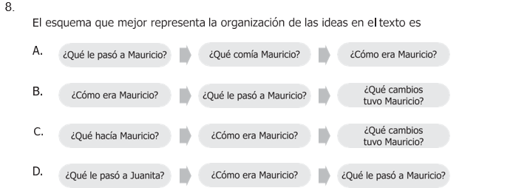

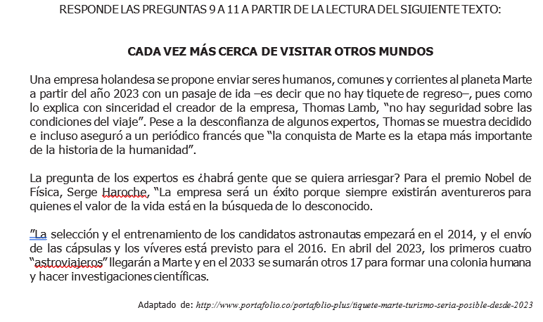

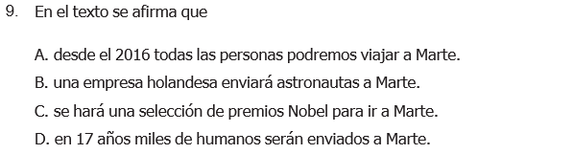

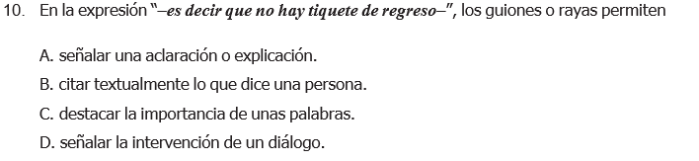

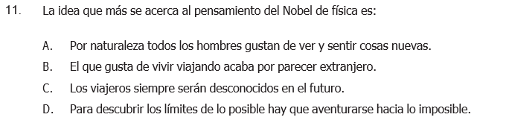

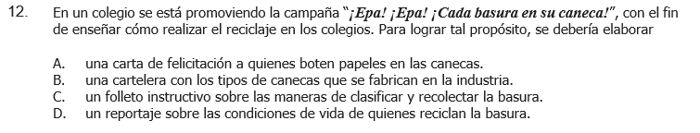

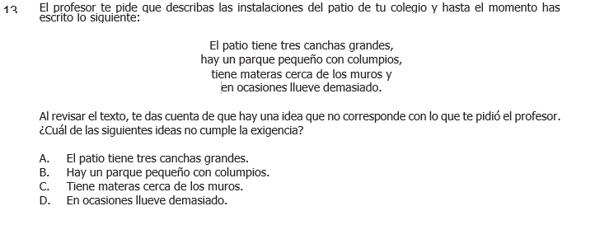

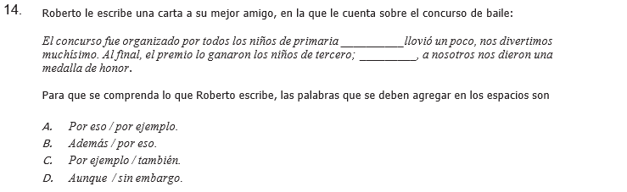

**DICTADO**

**______________________________________________________________________________________________________________________________________________________________________________________________________________________________________________________________________________________________________________________________________________________________________________________________________________________________________________________________________________________________________________________________________________________________________________________________________________________________________________________________________________________________________________________________________________________________________________________________________________________________________________________________________________________________________________________________________________________________________________________________________________________________________________________________________________________________________________________________________________________________________________________________________________________________________**