

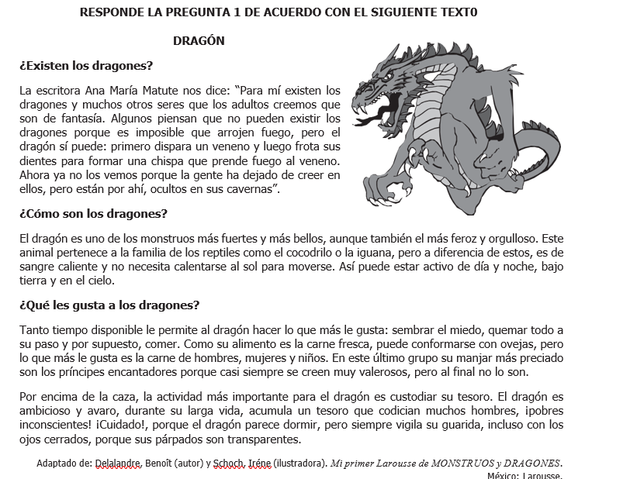

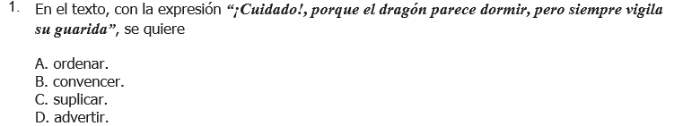

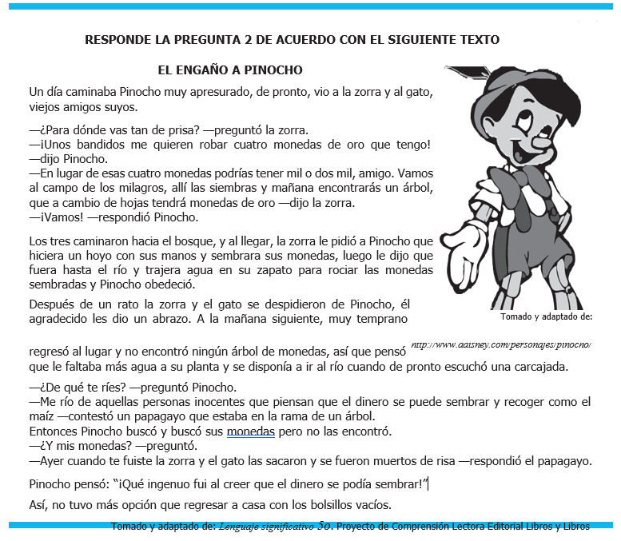



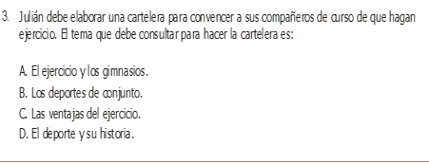

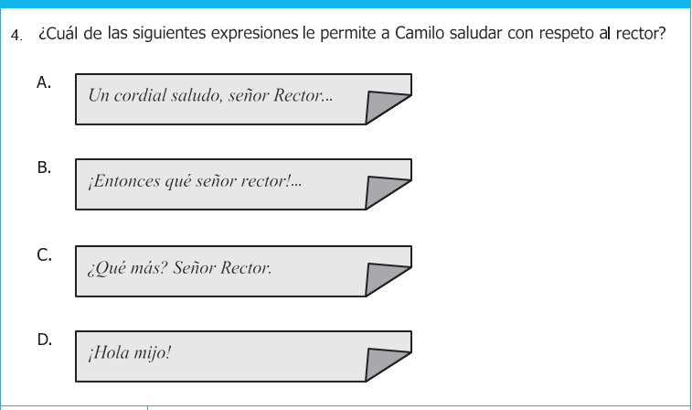

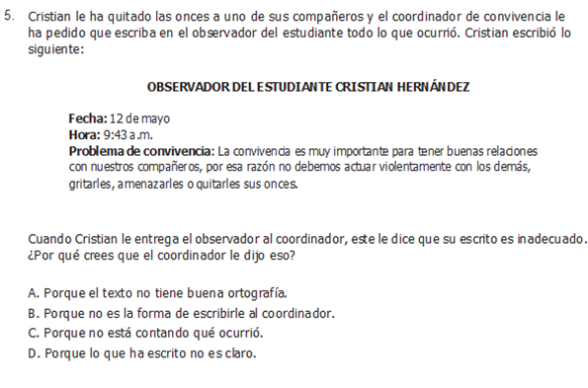

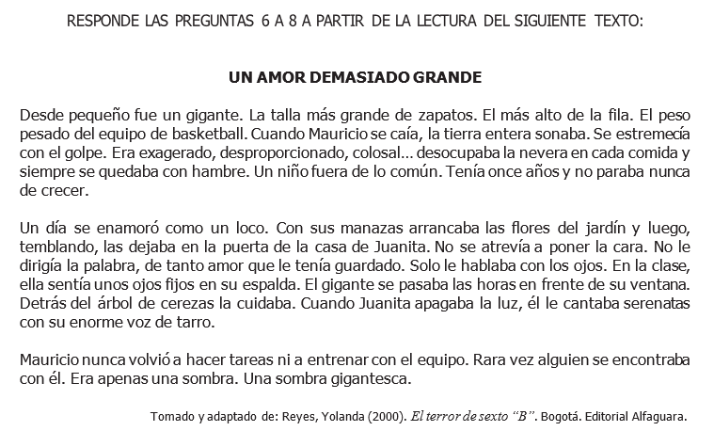

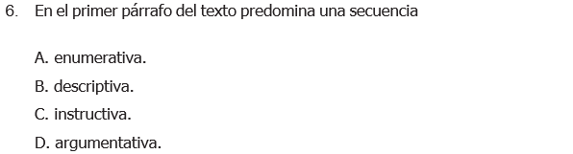

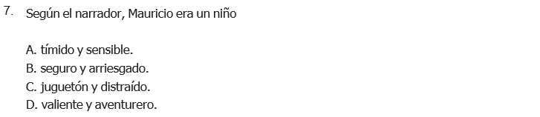

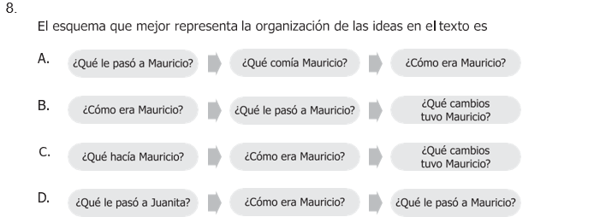

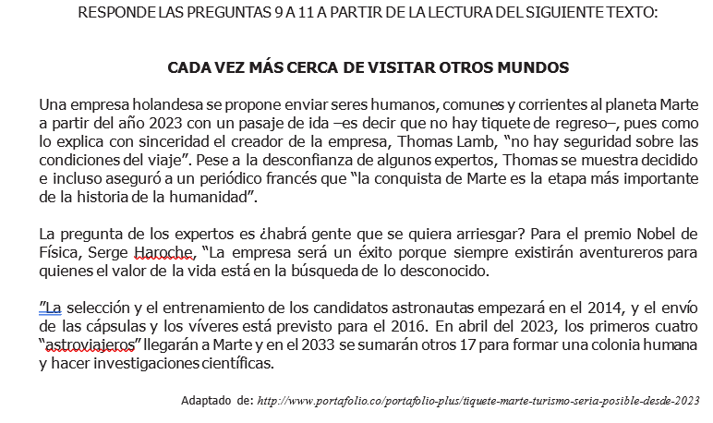

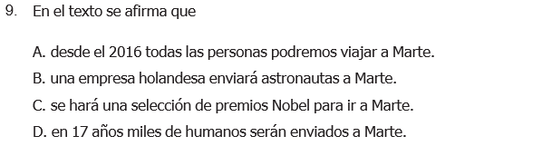

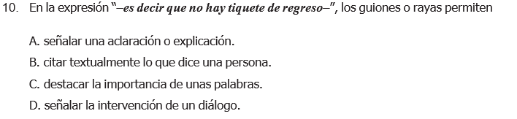

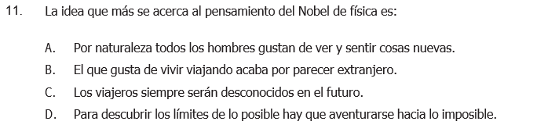

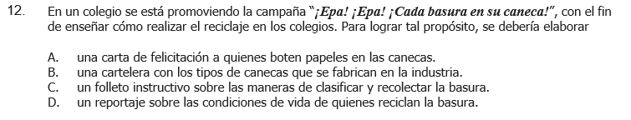

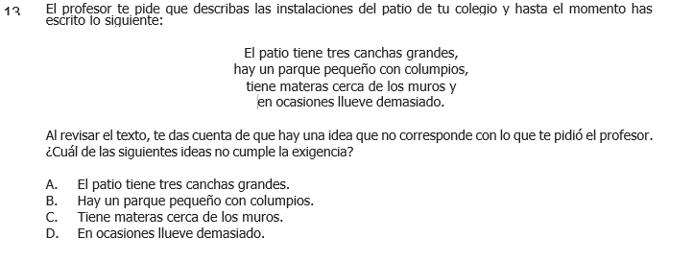

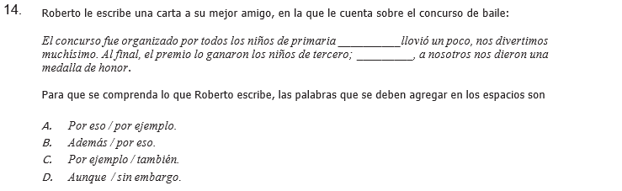

**DICTADO**

**______________________________________________________________________________________________________________________________________________________________________________________________________________________________________________________________________________________________________________________________________________________________________________________________________________________________________________________________________________________________________________________________________________________________________________________________________________________________________________________________________________________________________________________________________________________________________________________________________________________________________________________________________________________________________________________________________________________________________________________________________________________________________________________________________________________________________________________________________________________________________________________________________________________________________**