1 Click to listen the drag and drop the labels

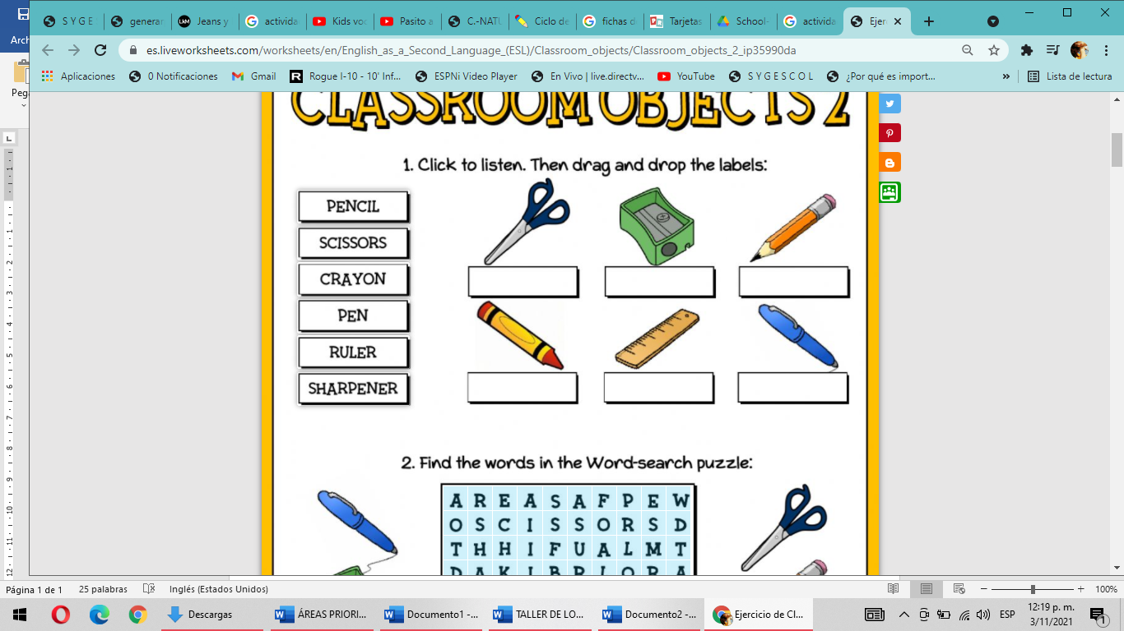

Pencil

Scissors

Crayon

Pen

Ruler

Sharpener

2 find the words in the word search Puzzle.

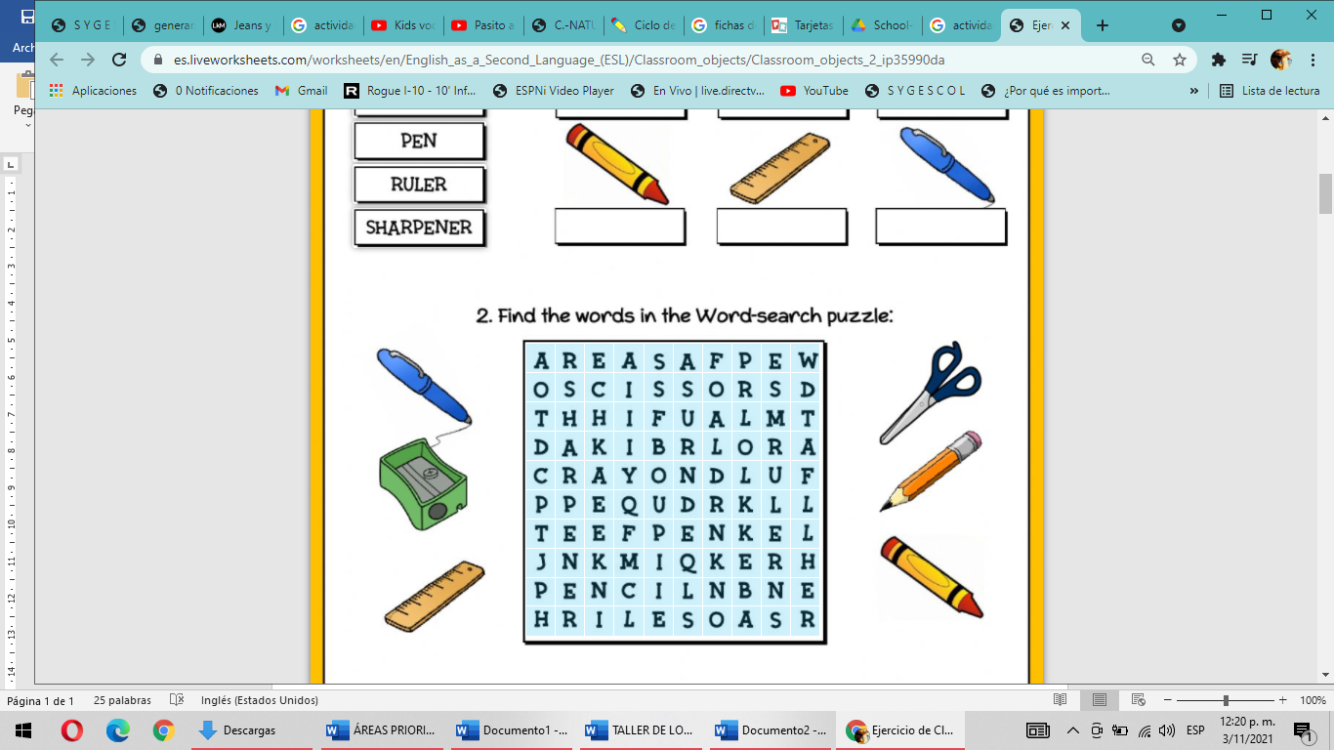

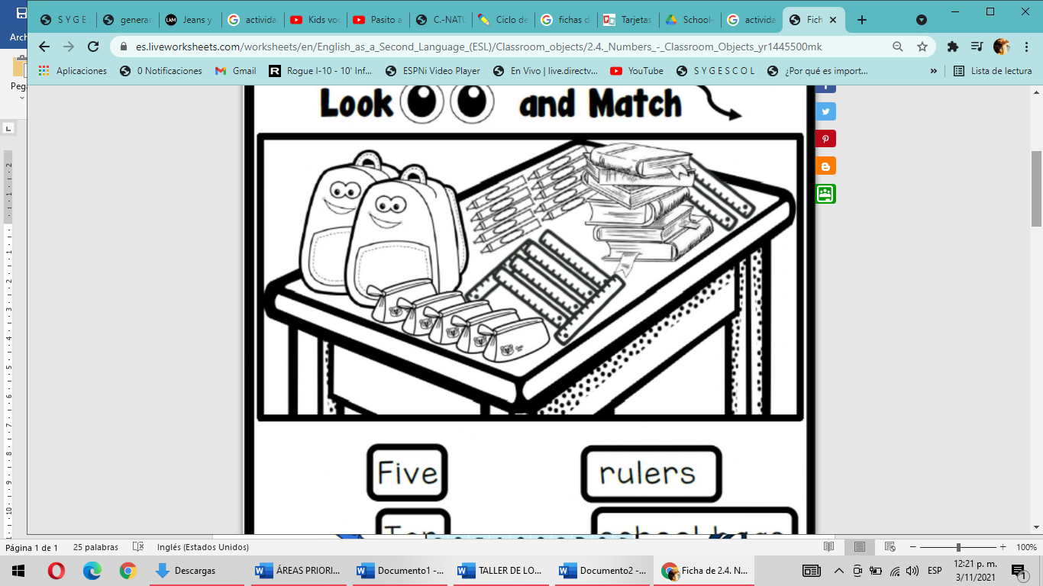

FIVE RULERS

TEN SCHOOL BAGS

SIX CRAYONS

TWO PENCIL CASES

ONE TABLE

EIGTH BOOKS