**TRABAJO DE INGLES**

**EXPRESSING OPINION**

**PRESENTADO POR:**

**VALERY NATALIA BENITEZ CABREJO**

**PROFESORA:**

**LILIANA MARTÍNEZ GRANADA**

**GRADO: 9°2**

**I.E. MIGUEL DE SEERVANTES SAAVEDRA**

**IBAGUÉ**

**SEPTIEMBRE**

**2021**

EXERCISES

2. Answer the next questions

A. Are you listening to music as you read this?

RTA/ NOT

B. Answer these questions: Are the sentences true or false?

1. British teenagers prefer the radio to YouTube videos.

True False

2. Lots of people in the UK download music.

True False

3. The O2 is the largest live music venue in the world.

True False

4. There are free music festivals in the UK every year.

True False

5. One Direction won a television music competition.

True False

6. Classical music helped to solve a problem in a British shopping centre.

True False

3. Find the words in the wordsearch.

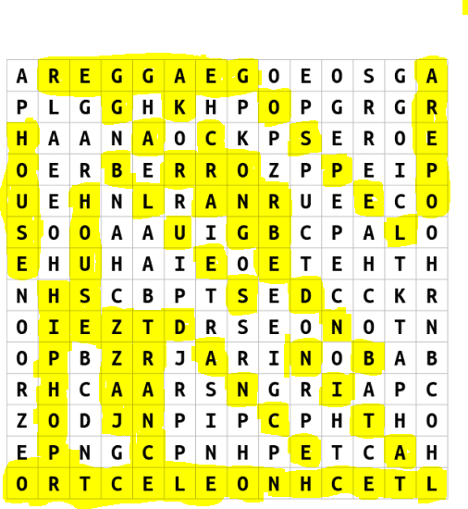

4. Write about your favourite kind of music, and one of the singers that you like a lot, use some phrases to express your opinión

My favorite type of music is trap and my favorite singer is duki

5. Choose one topic to organize a short presentation using words to express opinions, prepare slides to do the exercise.

<file:///C:/Users/LIZETH%20VALENTINA/Downloads/INGLES%20VIERNES-convertido.pdf>

ABRIR EL LINK