**EXERCISES**

1. **Circle the correct words.**
2. We **has to / have to** answer the questions.
3. Emma **has to / have to** go to the studio.
4. Do you **has to / have to** leave now?
5. No, I **doesn’t have to / don’t have** to.
6. Jay **doesn’t have to / don’t have** to wait for Emma.
7. He **has to / have to** help Carrie.

# Complete the dialogue with have to, has to, don’t have to, or doesn’t have to.

**Ramón:** Hurry up! We (1)have to get ready to leave. **Lara**: Leave? Where are we going?

**Ramón:** To the stadium. Don’t you remember?

**Lara:** No!

**Ramón:** You really (2)don´t have to listen to Carrie. L **Lara:** I do! Is Emma coming with us?

**Ramón:** Not today, she (3)has to go shopping and buy some gifts. **Lara:** Aren’t you going to buy any gifts?

**Ramón:** I bought all mine yesterday so I (4)don´t have to buy any more. **Lara:** Oh, right! Well I (5)have to get something for Alex. **Ramón:** Well do that later. We (6)have to go now or we’ll be late.

**Lara:** Please don’t tell Carrie I didn’t remember. She (7) doesn´t have to know.

**Ramón:** OK, but let’s go!

# Complete the following sentences with have/has to or don’t doesn’t have to

1. James is a smart guy, he has to (study) a lot!
2. Lorenz and Susan live in a really old house, they have to (buy) a new one.
3. Do you really have to (speak) so fast? I

Have to (write down) every single word!

1. No, you don´t have to (write down) every word I say, just the most important ideas!
2. Oh, look at the time I have to_(run) or a I’ll loose the train!
3. You don´t have to (run), the train is going to be delayed.
4. She has a wonderful hair but she has to (wash) it every day.
5. We can share a taxi if you want to. You don´t have to (walk) home

# FILL IN THE BLANKS WITH HAVE TO-HAS T0

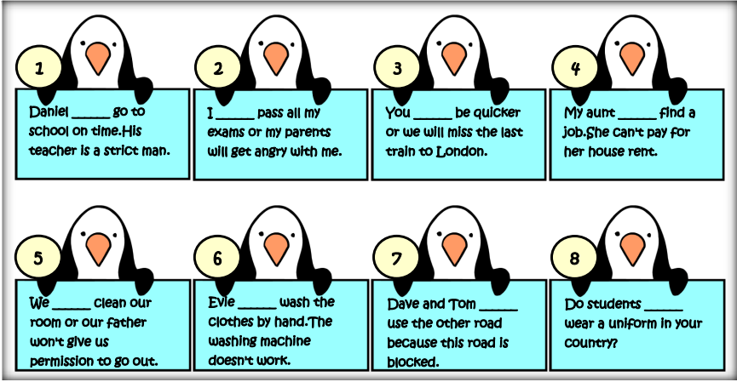

1. **READ AND COMPLETE WITH THE WORDS FROM THE BOX.**



Dishes -photos -lessons -- lunch – beach -tourists

–friend- accent

I’m in Rio de Janeiro, Brazil, and I’m having 1 lunch in a small café in the main square. The food here is delicious and a Portuguese **2 friend** is teaching me how to make some typical Portuguese **3 Dishes!** I’m also learning to surf and I have **4** **lessons** every day; I wanted to have a class today, but it’s raining, so I can’t. The people are really nice here and I’m learning lots of Portuguese, which is great, but my **5 accent** isn’t very good! There are lots of interesting things to see and I’m taking

hundreds of **6** **photos** to post on my blog. Check out the ones I took of the statue of Christ The Redeemer at the top of Corcovado Mountain.

They’re not bad, but there are always lots of other **7 tourists** taking photos of the statue too and it’s hard to take a good photo. Anyway, I have to go now because it’s finally stopped raining and the sun is shining, so I’m off to the **8 beach** for my surf lesson!

 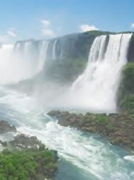 

Put the words in order to make questions (1–6) and then answer them.

1. is / Where / he / lunch / having / ?
2. Portuguese dishes / Who / to cook / teaching / is / him / ?
3. is / sport / he / to do / What / learning /?
4. language / What / learning / he / is / ?
5. of the statue of Christ / to take good photos / Why / is it difficult / ?
6. at the end of the blog post / Where / he / is / going?

Respuesta

1 Where is he having lunch?

2 Who is him to teaching cooking Portuguese dishes?

3 what he is sport to do learning?

4 what he is learning language?

5 why is it difficult to take good photos of the statue of Christ?

6 where he is at the end of the blog post going?